A Major Project Report on
CAPABILITY PROFILING AND OPTIMIZATION FOR VECHICLE ON-BOARD UNITS
A PROJECT REPORT
Submitted to
MALLAREDDY ENGINEERING COLLEGE AND MANAGEMENT SCIENCES
in partial fulfillment for the award of the degree
BACHELOR OF TECHNOLOGY
In
COMPUTER SCIENCE AND ENGINEERING (AI&ML)
BY
KALAKONDA PAVAN | (22UJ1A6624)
NARADASU VILASINI | (22UJ1A6644)
SANTHOSHI MISHRA | (22UJ1A6650)
VELAGALETY AKASH DUTT | (22UJ1A6658)
Under the esteemed Guidance of
MRS. CH. SWAPNA _{M.Tech}
Asst Professor

Department of Computer Science And Engineering (AI&Ml)
MALLAREDDY ENGINEERING COLLEGE AND MANAGEMENT SCIENCES
(Autonomous)
(AFFILIATED TO JAWAHARLAL NEHRU TECHNOLOGICAL UNIVERSITY, HYDERABAD)
APPROVED BY AICTE- ACCREDITED BY NBA (CSE, IT, EEE, ECE) &NAAC
KISTAPUR, MEDCHAL - 501401
April 2026

DECLARATION
We, undersigned, hereby declare that the project report “CAPABILITY PROFILING AND OPTIMIZATION FOR VEHICLE ON-BOARD UNITS”, submitted for partial fulfillment of the requirements for the award of degree of Bachelor of Technology of the Jawaharlal Technological University, Hyderabad is a bonafide work done by me under the guidance of CH. Swapna M.Tech (Asst professor) ,Department of Computer Science And Engineering(AI&Ml)
- We have followed the guidelines provided by the Institute in preparing the report.
- We have conformed to the norms and guidelines given in the Ethical Code of Conduct of the Institute.
- Whenever I have used materials (data, theoretical analysis, figures, and text) from other sources, I have given due credit to them by citing them in the text of the report and giving their details in the references. Further, I have taken permission from the copyright owners of the sources, whenever necessary.
I understand that any violation of the above will be a cause for disciplinary action by the institute and/or the University and can also evoke penal action from the sources which have thus not been properly cited or from whom proper permission has not been obtained. This report has not been previously formed the basis for the award of any degree, diploma or similar title of any other University.

Place: Kistapur ,Medchal
Date of Submission:

KALAKONDA PAVAN | (22UJ1A6624)
NARADASU VILASINI | (22UJ1A6644)
SANTHOSHI MISHRA | (22UJ1A6650)
VELAGALETY AKASH DUTT | (22UJ1A6658)

MALLA REDDY ENGINEERING COLLEGE AND MANAGEMENT SCIENCES
Kistapur (V),Medchal(Dt)-501401
__________________________________________________________________________
DEPARTMENT OF COMPUTER SCIENCE AND ENGINEERING (AI&ML)
MALLA REDDY ENGINEERING COLLEGE AND MANAGEMENT SCIENCES
(Autonomous)


BONAFIDE CERTIFICATE
This is to certify that the project report titled, “Capability Profiling And Optimization For Vehicle On – Board Units ” Submitted by KALAKONDA PAVAN (22UJ1A6624), NARADASU VILASINI (22UJ1A6644), SANTHOSHI MISHRA (22UJ1A6650), VELAGALETY AKASH DUTT (22UJ1A6658) During the academic year 2025-2026
Head of the Department  Signature:  Name:  Seal:  Date: | Guide:  Signature:  Name:  Designation:  Date

Submitted for the University Examination held on …………..
Internal Examiner  Signature:  Name:  Designation:  Date: | External Examiner  Signature:  Name:  College / Designation:  Date:

ACKNOWLEDGEMENT
It gives us great pleasure to thank MRS. CH. Swapna M.Tech Assistant Professor, Department of Computer Science And Engineering for the constant support and guidance given to us throughout the course of this project. He/she has been a constant source of inspiration for us. We also take the opportunity to acknowledge the contribution of Professor and Head, Department of Computer Science And Engineering(AI&Ml) Engineering, for his support and assistance during the development of the project. We also take this the opportunity to acknowledge the contribution of all faculty members of the department for their assistance and cooperation during the development of our project. We also thank all the Non Teaching Staff of the Department who helped us in the course of the project. Last but not the least, we acknowledge our friends for their encouragement in the completion of the project.
KALAKONDA PAVAN | (22UJ1A6624)
NARADASU VILASINI | (22UJ1A6644)
SANTHOSHI MISHRA | (22UJ1A6650)
VELAGALETY AKASH DUTT | (22UJ1A6658)

INSTITUTE VISION

The aspiration is to emerge as a premier institution in technical education to produce competent engineers and management professionals contributing to industry and society.

INSTITUTE MISSION
By Providing the Student Supporting Systems:

To impart updated pedagogical techniques with supportive learning environment and state- of-the-art facilities.
By Training the Students as per the Industry Needs:

To cultivate a culture of interdisciplinary approach, problem solving, innovative ecosystem and entrepreneurship by facilitating critical thinking, teamwork and research driven activities with hands-on-learning.
By Educating the Students about the Society Needs:
To instil ethical, social and environmental values through community engagement, resulting in sustainable development of society.
QUALITY POLICY

Ensuring quality in Teaching and Training through appropriate student support systems aligning the process towards needs of Industry and Society.

DEPARTMENT VISION

To provide quality education that produce technologically & ethically strong Engineers into the challenging digital world.

DEPARTMENT MISSION

1: To educate students in the emerging technology of Artificial Intelligence & Machine Learning.

2: To make students industry ready by developing their analytical & technical skills.

3: To inculcate academic environment for the students through self learning, E-learning & technical practices

PROGRAM EDUCATIONAL OBJECTIVES (PEOs)

PEO1 | Graduate would be proficient with strong fundamentals in engineering, science, and technology to establish successful career path in their life.
PEO2 | Graduate would be knowledgeable to plan, analyze, design, develop and test AI and ML based solutions for real world problems.
PEO3 | Graduate would be able to apply best practices in project building and exhibit leadership qualities with strong personality.
PEO4 | Graduate would possess the capability to become an entrepreneur or to pursue higher studies.
PEO5 | Graduate would adhere to professional ethics and become socially responsible human.

PROGRAM SPECIFIC OUTCOMES (PSOs)

PSO1 | Develop And Body-build Optimised Statement For Procedure Qualifier Utilise.
PSO2 | Use Implement and Method in Artificial Intelligence and Machine Learning for Resolution Multidisciplinary Problems.

PROGRAM OUTCOMES (POs)
PO1 | Engineering knowledge: Apply the knowledge of mathematics, science, engineering fundamentals, and an engineering specialization to the solution of complex engineering problems.
PO2 | Problem analysis: Identify, formulate, review research literature, and analyse complex engineering problems reaching substantiated conclusions using first principles of mathematics, natural sciences, and engineering sciences.
PO3 | Design/development of solutions: Design solutions for complex engineering problems and design system components or processes that meet the specified needs with appropriate consideration for the public health and safety, and the cultural, societal, and environmental considerations.
PO4 | Conduct investigations of complex problems: Use research-based knowledge and research methods including design of experiments, analysis and interpretation of data, and synthesis of the information to provide valid conclusions.
PO5 | Modern tool usage: Create, select, and apply appropriate techniques, resources, and modern engineering and IT tools including prediction and modelling to complex engineering activities with an understanding of the limitations.
PO6 | The engineer and society: Apply reasoning informed by the contextual knowledge to assess societal, health, safety, legal and cultural issues and the consequent responsibilities relevant to the professional engineering practice.
PO7 | Environment and sustainability: Understand the impact of the professional engineering solutions in societal and environmental contexts, and demonstrate the knowledge of, and need for sustainable development.

PO8 | Ethics: Apply ethical principles and commit to professional ethics and responsibilities and norms of the engineering practice.
PO9 | Individual and team work: Function effectively as an individual, and as a member or leader in diverse teams, and in multidisciplinary settings.
PO10 | Communication: Communicate effectively on complex engineering activities with the engineering community and with society at large, such as, being able to comprehend and write effective reports and design documentation, make effective presentations, and give and receive clear instructions.
PO11 | Project management and finance: Demonstrate knowledge and understanding of the engineering and management principles and apply these to one’s own work, as a member and leader in a team, to manage projects and in multidisciplinary environments.
PO12 | Life-long learning: Recognize the need for, and have the preparation and ability to engage in independent and life-long learning in the broadest context of technological change.

COURSE OUTCOMES (For Project stage-2)

CO1 | Demonstrate the technical knowledge of their selected project topic.
CO2 | Undertake problem identification, formulation and solution.
CO3 | Design engineering solutions to complex problems utilizing a systems approach.
CO4 | Work with practicing engineers
CO5 | Demonstrate the knowledge and skills acquired during the course work

ABSTRACT
The advancement technology of transportation systems has significantly increased the demand for efficient and reliable vehicle on-board units (OBUs), which act as central hubs for communication, data processing, and decision support within modern vehicles. On-Board Units (OBUs) manage tasks like navigation, communication, safety notifications, and entertainment. However, not all OBUs are the same—some have strong processing power and fast communication, while others are more limited. This dual approach not only strengthens the current performance of OBUs but also ensures for next-generation mobility technologies, including 5G-enabled V2X networks, autonomous driving frameworks, and smart traffic management systems. The research implements and evaluates four regression models—Decision Tree Regressor, Orthogonal Matching Pursuit (OMP), K-Nearest Neighbors (KNN), and a hybrid Random Forest. Tools like Pandas, NumPy, scikit-learn, TensorFlow, and Matplotlib. Each model is rigorously assessed using standard evaluation metrics such as Mean Absolute Error (MAE), Mean Squared Error (MSE), Root Mean Squared Error (RMSE), and R² Score. The research also integrates a user-friendly interface developed using Tkinter, enabling real-time CSV data uploads and predictive visualization. we concentrate on two main concepts: capability profiling and optimization. To overcome these challenges Capability profiling involves identifying and analyzing the strengths and weaknesses of OBUs in terms of processing power, communication bandwidth, storage, and energy efficiency. Optimization uses this knowledge to assign tasks in the smartest way possible, ensuring quicker responses, lower energy use, and smoother coordination between vehicles and road infrastructure. By combining profiling and optimization, we can make smarter decision-making and efficient resource. It enhances system performance, reliability, and safety while supporting the vision of intelligent transportation systems.

TABLE OF CONTENT
Section | Title | Page No.
 | List of Figures | i
 | List of Abbreviations | ii
CHAPTER 1 | INTRODUCTION | 1
1.1 | Introduction to the Project | 1
1.2 | Background of the Study | 2
1.3 | Problem Statement | 2
1.4 | Objectives of the Project | 3
1.5 | Scope of the Project | 3
1.6 | Organization of the Report | 4
CHAPTER 2 | LITERATURE SURVEY | 5
2.1 | Introduction | 12
2.2 | Review of Existing Systems | 13
2.3 | Limitation of Existing System | 14
2.4 | Proposed System Overview | 15
CHAPTER 3 | SYSTEM ANALYSIS AND DESIGN | 16
3.1 | System Requirements | 16
3.2 | Feasibility Study | 17
3.3 | System Architecture | 18
3.4 | Data Flow Diagram (DFD) | 19
3.5 | UML Diagrams | 20
3.6 | Dataset / ER Diagram | 27
CHAPTER 4 | IMPLEMENTATION | 28
4.1 | Tools and Technologies Used | 28
4.2 | Module Description | 29
4.3 | Algorithm / Methodology | 30
4.4 | System Implementation | 32
CHAPTER 5 | SOURCE CODE | 34
CHAPTER 6 | RESULTS AN DISCUSSION | 44
6.1 | System Testing | 44
6.2 | Output Screens | 45
6.3 | Performance Analysis | 46
6.4 | Advantages of the System | 48
CHAPTER 7 | CONCLUSION & FUTURE SCOPE | 49
7.1 | Conclusion | 49
7.2 | Future Enhancements | 50
 | REFERENCES | 52

LIST OF FIGURES

Figure  No. | Particulars | Page No.
1 | Fig 1.1 Vehicle Infrastructure co-oparative system(VICS) | 1
2 | Fig 3.3.1 System Architecture of Proposed Iot | 19
3 | Fig 3.4 Data Flow Diagram | 20
4 | Fig 3.5.1 Use Case Diagram | 21
5 | Fig 3.5.2 Class Diagram | 22
6 | Fig 3.5.3 Activity Diagram | 23
7 | Fig 3.5.4 Sequence Diagram | 24
8 | Fig 3.5.5 Deployment Diagram | 25
9 | Fig 3.5.6 Component Diagram | 26
10 | Fig 3.6 Database Design / Er Diagram | 27
11 | Fig 4.1 Tools & Technologies | 28
12 | Fig 4.2 Module Description | 30
13 | Fig 4.3 (OBU) Optimization Methodology | 31
14 | Fig 6.2 Output Screens | 46
15 | Fig 6.3 Performance Analysis | 47

LIST OF ABBREVIATIONS

Abbreviation | Full Form
OBU | On-Board Unit
ITS | Intelligent Transportation Systems
V2V | Vehicle-to-Vehicle
V2I | Vehicle-to-Infrastructure
GPS | Global Positioning System
CAN | Controller Area Network (often mentioned with CAN bus)
OMP | Orthogonal Matching Pursuit (a regression model)
MAE | Mean Absolute Error (an evaluation metric)
MSE | Mean Squared Error (an evaluation metric)
RMSE | Root Mean Squared Error (an evaluation metric)

CHAPTER 1
INTRODUCTION
  - Introduction to the Project
With growing concern regarding the traffic congestion problem and traffic safety issues, intelligent vehicle and connected vehicle techniques have become mainstream trends in today’s automotive industry. As a result, real-time driving behavior monitoring has attracted significant attention in recent years as it can provide important reference input for intelligent vehicle control, as well as microscopic traffic estimation and control. On one hand, to support the timely response of intelligent vehicle control and ensure the safety of autonomous driving systems, it is necessary to realize driving behavior recognition for smart vehicles in real time [1]. On the other hand, dynamically monitoring the driving behavior of probe vehicles could provide fine-grained and efficient traffic information for real-time traffic estimations [2]. When recognizing driving behavior, two types of driving behavior are usually considered: is the first type includes lateral driving behaviors, such as lane changing and lane keeping, and the other includes longitudinal driving behaviors, including acceleration, braking, and stopping or cruising. Monitoring longitudinal driving behaviors can provide real-time data on the movement status of a vehicle, which is very useful for monitoring traffic flow and controlling congestion.
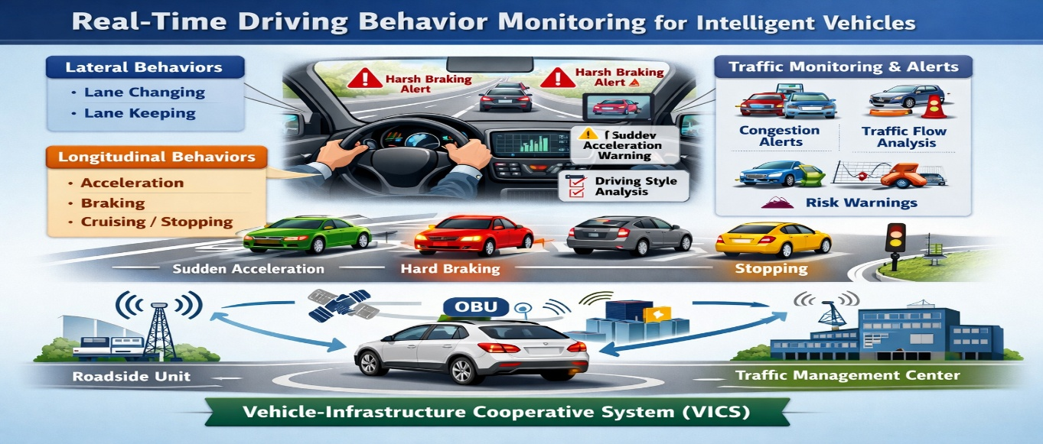
Fig 1.1 Vehicle-infrastructure cooperative system(VICS)
In addition, the identification of these longitudinal driving behaviors could help identify undesirable driving behaviors, such as sudden acceleration, sharp braking, etc., so as to achieve early warnings and risk management for traffic accidents. Moreover, such information can be used to evaluate a driver’s driving style [3], thus helping the driver to identify and improve bad driving habits and improve driving safety.With the development of the vehicle-infrastructure cooperative system (VICS) [4] in recent years, the OBU (on-board units) has become an essential communication device and is responsible for collecting vehicle-side information and transmitting it to external equipment.

  - Background of the Study
Capability profiling and optimization for vehicle On-Board Units (OBUs) have become essential with the rapid advancement of intelligent transportation systems and connected vehicle technologies. OBUs serve as critical components that collect, process, and transmit real-time vehicle and traffic data to infrastructure and other vehicles. However, due to limited computational resources, energy constraints, and varying network conditions, OBUs often face performance challenges. Capability profiling helps in identifying the processing power, memory usage, communication efficiency, and latency characteristics of OBUs under different operating conditions. This information is crucial for optimizing resource allocation, improving data handling efficiency, and ensuring reliable communication. Optimization techniques such as adaptive data processing, efficient communication protocols, and edge computing integration can significantly enhance OBU performance. Ultimately, improving OBU capability ensures better traffic management, enhanced driving safety, and more efficient vehicle-infrastructure cooperation in modern smart transportation systems.

1.3 Problem Statement
Vehicular onboard units generate massive volumes of high-resolution data that remain underutilized due to the lack of efficient predictive models. Current systems often fail to fully harness this data for forecasting vehicle behavior, energy demands, or performance capability. The absence of accurate regression-based systems that can map complex onboard parameters to actionable outcomes results in suboptimal resource usage, increased maintenance costs, and poor decision-making in intelligent transportation systems.
The problem becomes more challenging when the system needs to adapt to diverse driving environments, changing sensor inputs, and inconsistent data patterns. Traditional statistical methods or isolated ML models fall short in modeling nonlinearities and interactions between onboard features. Furthermore, usability gaps such as non-interactive interfaces or the need for extensive manual preprocessing limit the practical deployment of such systems in real-world scenarios.
Hence, there exists a need to design and implement a comprehensive machine learning-based regression system that can pre-process raw vehicular data, learn meaningful patterns, and generate reliable predictions. The system must also be flexible enough to incorporate evolving data and must support integration into applications used by companies for real-time analytics.

1.4 Objectives of the Project
1. To analyze the performance capabilities of OBUs
Evaluate processing power, memory usage, communication efficiency, and response time under different driving and traffic conditions.
2. To develop a capability profiling framework
Design a systematic method to monitor and measure OBU performance metrics in real time.
3. To identify performance bottlenecks
Detect limitations such as latency issues, bandwidth constraints, and resource inefficiencies affecting OBU operations.
4. To optimize resource utilization
Implement techniques to efficiently manage CPU, memory, and energy consumption within OBUs.
5. To enhance communication efficiency
Improve data transmission between vehicles and infrastructure using optimized protocols.
6. To support real-time decision making
Ensure OBUs can process and deliver critical information quickly for intelligent vehicle control and safety systems.
7. To integrate advanced technologies
Explore the use of edge computing, AI, or adaptive algorithms for improving OBU performance.
1.5 Scope of the Project
The scope of the project “Capability Profiling and Optimization for Vehicle On-Board Units (OBUs)” focuses on analyzing, evaluating, and improving the performance of OBUs used in intelligent and connected vehicle systems. The project covers the study of key performance parameters such as processing speed, memory utilization, communication latency, and energy efficiency under different traffic and environmental conditions. It includes the development of a capability profiling framework to monitor real-time OBU behavior and identify system limitations.

The project also explores optimization techniques to enhance the efficiency of OBUs, such as adaptive resource management, efficient data transmission methods, and integration with edge computing technologies. Emphasis is placed on improving communication between vehicles and infrastructure to support real-time traffic monitoring, safety applications, and intelligent decision-making systems.
Additionally, the scope includes evaluating how optimized OBUs contribute to better traffic flow, reduced congestion, and enhanced road safety. However, the project is limited to simulation or prototype-level implementation and does not involve large-scale real-world deployment. Overall, it provides a foundation for future advancements in smart transportation systems and connected vehicle technologies.
1.6 Organization of the Project
- Useful in vehicle manufacturing companies for analyzing performance across different vehicle variants during testing.
- Can be deployed by fleet management systems to monitor and predict vehicle service schedules based on onboard unit metrics.
- Beneficial for logistics companies to forecast delivery times, fuel consumption, and driver efficiency.
- Can assist in predictive maintenance systems where the model signals early alerts for engine, battery, or brake anomalies.
- Applicable in electric vehicle infrastructure planning by analyzing energy demand patterns using regression predictions.
- Suitable for government or municipal planning agencies to evaluate road and traffic conditions indirectly from aggregated vehicular data.
- Helpful in insurance analytics to model driver behavior and calculate dynamic premiums based on predicted performance risk.
- Supports autonomous driving systems by modeling and simulating vehicle behavior under varying sensor conditions.
- Can be used in vehicular simulations for academic or industrial research by replacing costly physical testing with model-driven forecasts.

CHAPTER 2
LITERATURE SURVEY
Shankar R et. al [1] (2012) proposed an optimization-based charge blended energy management strategy for PHEVs. The work demonstrated feasible component downsizing while ensuring performance. Their improved equivalent consumption model enhanced energy efficiency during real driving.
Jiménez F et. al [2] (2014) developed a real-time energy optimization framework using live road and traffic data. The approach dynamically adjusts driving strategies to minimize fuel use. Results showed significant improvements over traditional control systems.
Wang y et. al [3] (2017) introduced a carbon-tax-driven optimization model for cold-chain logistics routing. The model effectively reduced emissions and operational cost. It supports sustainable transportation planning and environmentally friendly logistics.
Levermore T et. al [4] (2017) presented a real-time velocity optimization model to reduce vehicle energy use. The method leveraged predicted traffic flow for speed adjustments. Simulation results confirmed measurable fuel and energy savings.
Hur D-J et. al [5] (2019) optimized flow distribution in multi-channel inverter cooling systems for EVs. Their desirability-based optimization improved thermal performance and component lifespan. This contributes to enhanced EV reliability.
Kent T et. al [6] (2020) developed a connected autonomous vehicle testbed enabling data-driven validation. The platform supports real-time experimentation, integration, and system tuning. Findings revealed key challenges in autonomous vehicle deployment.
Baz A et. al [7] (2020) proposed an optimized intersection management model for autonomous and mixed vehicle flows. Their method minimized delay and ensured smooth traffic movement. Results confirmed improved efficiency under connected vehicle conditions.
Shokravi H. et al. [8] (2020) reviewed vehicle classification techniques and intelligent sensing-based transportation approaches. The study explored machine learning, IoT, and advanced analytics applications. Future research opportunities in automated monitoring and smart mobility were identified.
Zhu Y. et al. [9] (2020) released the VOCC dataset to benchmark onboard computation capability of smart vehicles. The dataset enables standardized evaluation of vehicle processing systems. It supports research and development in autonomous and connected vehicle computing.

Vo-Duy T. et al. [10] (2020) introduced an evaluation platform for real-time motion controllers in electric vehicles. The framework validates controller stability, responsiveness, and control accuracy. Results enhance reliability and performance in EV control systems.
Xu N et. al [11] (2021) presented a detailed review on eco-driving theory, capability evaluation, and training. Their findings highlight the effectiveness of driver behavior optimization in fuel reduction. Research gaps and future technological integration needs were noted.
Ghoul T et. al [12] (2021) applied reinforcement learning for trajectory optimization in connected vehicles. The approach reduces collision potential through adaptive behavior adjustment. Simulation results demonstrated meaningful safety improvements.
Ameen H.A. et al. [13] (2021) analyzed driving safety profiles using vehicle OBD data within V2V systems. Their classification model detects unsafe driving behaviors for proactive intervention. The framework enhances cooperative driving safety and communication systems.
Shan D. et al. [14] (2021) proposed a hybrid traffic data extraction method using UAV video validated with onboard data. The model improved detection accuracy and parameter estimation. This supports intelligent traffic control and monitoring systems.
Bethaz P. et al. [15] (2021) explored data-driven approaches to enhance commercial vehicle operation and fleet management. Their framework supports predictive maintenance, route optimization, and system automation. The study emphasizes analytics-based intelligent vehicle ecosystems.
Bučko B. et al. [16] (2021) examined the role of data interoperability in vehicle-to-infrastructure communication. Their findings highlight technical and integration challenges for smart mobility systems. The work contributes toward large-scale intelligent transport deployment.
Yu G et. al [17] (2021) optimized platooning car-following models in connected driving environments. The model improved stability, reduced energy consumption, and enhanced flow efficiency. The findings support automated platoon-based transportation systems.
Chen Y et. al [18] (2021) investigated the effects of aerodynamics, mass, and auxiliary loads on autonomous vehicle energy efficiency. Simulation-based analysis quantified performance trade-offs. These insights guide optimized autonomous EV design.
Adelantado F. et al. [19] (2022) reviewed Internet of Vehicles architecture and real-time optimization algorithms for smart cities. Their work supports adaptive routing, communication, and coordination strategies. The study highlights IoV as a core enabler of intelligent mobility.

Pusztai Z et. al [20] (2022) proposed a model-based optimized driving strategy for lightweight vehicles. The simulations showed reduced energy consumption and improved operational efficiency. This model supports integration into next-generation smart vehicle control systems.
Rabieinejad F et. al [21] (2022) analyzed connected vehicles and adaptive optimization systems for traffic safety. Their results demonstrated reduced crash risk and improved decision responses. The study highlights the safety value of connected vehicle ecosystems.
Ayob A et. al [22] (2022) optimized energy management strategies for electric buses using real-time operation data. The research demonstrated improved travel range and battery utilization. The framework supports sustainable public electric mobility.
Salunkhe A et. al [23] (2022) developed a real-time traffic sign classification model for autonomous vehicles using lightweight CNNs. Their model improved recognition accuracy while maintaining computational efficiency. The approach enhances onboard intelligent perception.
Kadhem H.H et. al [24] (2023) proposed an optimization-based routing and lane selection framework using intelligent vehicle data. Their results showed improved mobility performance and reduced delays under dynamic traffic. The method supports intelligent transportation management.
Hsu C.-C et. al [25] (2023) optimized vehicle dynamics monitoring using IoT sensor fusion techniques. Their model enhanced tracking accuracy and stability in motion analysis. The work advances real-time vehicular monitoring and diagnostics.
Bhandari S et. al [26] (2023) presented a review of machine learning applications in vehicle automation and monitoring. The study emphasized AI-driven safety, detection efficiency, and predictive maintenance. Research gaps and deployment needs were identified.
Tanveer M et. al [27] (2023) proposed reinforcement learning-based adaptive cruise control for autonomous vehicles. Their controller demonstrated safer maneuvering during dynamic operations. Testing showed reduced collision probability under uncertain driving behavior.
Gogineni E et. al [28] (2023) investigated multi-source sensor fusion for vehicle system monitoring using intelligent processing methods. Their approach improved noise resistance and signal accuracy. The study enhances perception reliability in dynamic driving.
Negoro G et. al [29] (2023) developed an AI-assisted dynamic planning model for energy-efficient routing. Their work reduced travel cost and consumption under constrained transport scenarios. The model supports real-time navigation systems.

Baqir G et. al [30] (2023) proposed a hybrid optimization algorithm for connected vehicle energy planning. Their model improved routing and preserved battery resources under varying conditions. The findings highlight multi-objective optimization importance.
Makhdoom et. al [31] (2023) applied blockchain-based data validation for secure vehicle-to-everything communication. The system demonstrated reduced security vulnerabilities and higher confidence in shared mobility data. The model strengthens security in intelligent transportation.
Raja G et. al [32] (2023) investigated structural optimization in connected vehicle data architecture. Their study improved computation efficiency during distributed processing. The findings support scalable deployment in smart transport ecosystems.
Park H. et.al [33] (2024) implemented network-based energy-aware routing in platoons of automated vehicles. Their strategy reduced emissions and improved movement stability. The results contribute to coordinated low-energy vehicular systems.
Al-Falahi A et. al [34] (2024) presented a multi-layer intelligent system for EV fleet load balancing. Their computation techniques improved power distribution and charging prioritization. This supports efficient EV energy ecosystem implementation.
Liu T et. al [35] (2024) proposed an optimized perception and decision-making model based on sensor fusion algorithms. Their results showed enhanced real-time decision stability and improved path precision. The approach strengthens autonomous driving safety.
Chen Y et. al [36] (2024) optimized power distribution methods in hybrid electric autonomous vehicles. Their model improved efficiency without compromising maneuver handling. The framework advances hybrid vehicle intelligence.
Mahmoud M et. al [37] (2024) developed a lightweight CNN-based driver monitoring and motion detection framework. Results improved movement accuracy and behavioral classification under real traffic. The model enhances safety and human–machine interaction.
Xu X et. al [38] (2024) introduced a real-time deep learning-based advisory speed optimization system. Their model improved travel-time efficiency under mixed traffic density. The outcomes demonstrate potential for adaptive smart routing.
Ding Y et. al [39] (2024) proposed a predictive optimization framework for traffic motion planning in connected EV fleets. Results showed reduced idle energy and minimal grid load fluctuation. The study supports eco-based scheduling.

Zhang F et. al [40] (2024) designed a dynamic network digital twin for traffic flow forecasting and optimization. Their study demonstrated improved control during uncertainty and prediction volatility. The model boosts adaptive transportation planning.
Li H et. al [41] (2024) presented an adaptive real-time control algorithm for autonomous vehicle path planning. Their approach improved trajectory smoothness and reduced computational delay. The findings support safe execution in dynamic road environments.
Singh S et. al [42] (2024) proposed an intelligent traffic-aware EV route optimization system. Their model reduced charge consumption and improved estimated arrival performance. The study supports smart-grid cooperative navigation.
Kim H et. al [43] (2024) introduced a wireless communication-based driver assistance framework for human-vehicle shared control. Testing showed improved lane maintenance and reduced reaction time errors. The model enhances the integration of human factors in automation.
Rahman et. al [44] (2024) developed a sensor-fusion-based vehicle behavior prediction model using deep neural layers. Their system improved hazard detection accuracy in autonomous driving environments. The findings emphasize predictive safety mechanisms.
Khan M et. al [45] (2024) optimized EV charging and discharging under renewable grid constraints. Their hybrid scheduler reduced charging cost and ensured stable electricity flow. The method contributes to energy-aware vehicular infrastructure.
Ebrahimi M et. al [46] (2024) proposed a multi-objective optimization framework for routing electric autonomous fleets. Their system improved transportation efficiency and minimized total carbon emissions. The model supports sustainable mobility deployment.
Zhao Y et. al [47] (2024) introduced a vehicle state estimation algorithm using Kalman-based residual filtering. Their model reduced estimation error during sudden motion variations. The study supports robust control system design.
Basha A et. al [48] (2024) evaluated traffic congestion mitigation using intelligent V2X platforms. Results showed improved flow stability and reduced idling emissions. The approach strengthens connected mobility solutions.
Nasir H et. al [49] (2024) proposed a digital-twin-oriented autonomous testing framework. Their results improved simulation accuracy and testing reliability before field deployment. The work supports scalable autonomous validation systems.

Moreno L et. al [50] (2024) developed a cooperative vehicular learning framework for fleet-level optimization. Their system reduced inter-vehicle communication burden and enhanced global learning accuracy. The study supports distributed autonomy.
Huang D et. al [51] (2024) researched AI-based energy recovery optimization in regenerative braking for EVs. Their solution improved battery longevity and enhanced deceleration stability. The approach enhances energy recycling performance.
Arora S et. al [52] (2024) proposed a cloud-integrated autonomous vehicle navigation architecture. Their model reduced computation load on onboard processors while improving decision precision. The results demonstrate efficient distributed autonomy.
Oladayo A et. al [53] (2024) developed an adaptive safety monitoring model using behavior prediction and sensor validation. Results demonstrated improved collision-prevention reliability. The model reinforces risk-aware driving intelligence.
Fu J et. al [54] (2024) evaluated the long-term sustainability of EV fleet operations under demand uncertainty. Their multi-layer approach optimized charging coordination and operational strategy. The findings support resilient deployment.
Yousef M et. al [55] (2024) proposed a real-time lane geometry estimation model using neural-enhanced image processing. Their system improved lane curvature identification accuracy under adverse conditions. The model supports safer AV perception.
Jin R et. al [56] (2024) introduced a knowledge-based reinforcement learning system for navigation planning. Results demonstrated reduced optimization time and improved route efficiency. The study merges decision learning with autonomous control.
Alrukhayyal A et. al [57] (2024) analyzed EV infrastructure readiness using multi-criteria decision models. Their results highlighted the importance of integrated policy, technology, and economic collaboration. The findings guide deployment strategies.
Safi S et. al [58] (2024) studied multi-vehicle platooning optimization using cooperative distributed control. The model showed reduced fuel usage and safer inter-vehicle spacing. The approach improves roadway efficiency.
Prajapati M et. al [59] (2024) developed a lightweight optimized vision tracking framework for compact AV platforms. Their solution reduced resource usage while maintaining high tracking accuracy. The study supports cost-effective intelligent systems.

Rehman A et. al [60] (2024) proposed an intelligent fault diagnosis framework for EVs using automated sensor analytics. Their approach improved maintenance predictability and reliability. The model contributes to future smart diagnostics.
Visconti P et. al [61] (2025) presented innovations in driver monitoring and on-board systems designed for smart-road networks. Their review compared commercial and research solutions, demonstrating rapid integration trends in IoV-based safety systems.
Mansouri N et. al [62] (2025) optimized hydrogen hybrid electric vehicle control using GPS-based speed prediction. Their work improved energy consumption and extended driving range, demonstrating hybrid adaptive control feasibility.
Wang T et. al [63] (2025) analyzed dynamic stability for multi-vehicle connected systems. Their optimizations enhanced cooperative driving stability in heterogeneous traffic environments.
Bilban M et. al [64] (2025) improved autonomous vehicle decision-making using enhanced proximal policy optimization. Results showed improved control precision and adaptation in uncertain road conditions.
Zhang B et. al [65] (2025) applied genetic optimization for railway maintenance vehicle speed management. Their multi-objective strategy reduced operational time and improved infrastructure safety.
Wang X et. al [66] (2025) reviewed major state estimation techniques used in autonomous vehicles. Their work proposed a unified taxonomy linking algorithm type to vehicle behavior and sensing modality.
Wang D et.al [67] (2025) optimized EV routing under energy uncertainty using time-window constraints. Their robust model improved logistical resilience and operational efficiency.
Cao H et.al [68] (2025) optimized modular public transport operations using strategic coupling and short-turning. Their method enhanced fleet efficiency and passenger service reliability.
Husyeva et.al [69] (2025) surveyed data-driven vehicle driving analysis. Their review identified emerging machine learning trends for driving efficiency, safety analytics, and behavior profiling.
Arslan M et.al [70] (2025) optimized lightweight EV battery structure design. Their hybrid multi-objective model demonstrated improved crashworthiness and weight reduction.
Palamutçuoğlu B et.al [71] (2025) solved capacity-constrained routing using genetic algorithms with a carbon-aware model. Their approach improved sustainability in logistics operations.
Almutairi A et.al. [72] (2025) developed a traffic-sensor-assisted routing model for real-time navigation. Their system improved computational reliability and route safety in intelligent transportation networks.
Youssef B. et.al [73] (2025) implemented an adaptive health monitoring strategy for diesel particulate filters using soot-sensor analytics. Results improved long-term reliability in fleet vehicles.
Šarkan B et.al [74] (2025) evaluated inconsistencies in vehicle fuel consumption documentation. Their findings emphasized regulatory gaps affecting emissions compliance.
Dafhalla A et.al [75] (2025) optimized wireless ad-hoc networking throughput for inter-vehicle communication. Their work supports scalable smart-vehicle connections.
Kavitha C et.al [76] (2025) estimated hybrid vehicle battery health using intelligent regenerative braking optimization. Testing demonstrated improved battery lifespan and energy efficiency.
Sardar S et.al [77] (2025) retrieved live EV field data and estimated equivalent circuit parameters using particle swarm optimization. Their model improved accuracy in battery behavior modeling.
Dafhalla A et.al [78] (2025) evaluated routing protocol performance under delay-sensitive constraints. Their findings supported efficient QoS management in vehicular communication.
Nasri S et.al [79] (2025) conducted a global assessment of EV charging infrastructures. Their work highlighted renewable energy integration strategies and deployment challenges.
Kiani et.al wa[80] (2025) designed a renewable hybrid energy system supporting simultaneous electricity and heat distribution with EV charging capability. Their evaluation covered multiple weather-dependent configurations.
2.1 Introduction
The rapid evolution of the Automotive Industry has transitioned vehicles from mechanical machines into "Computers on Wheels." Central to this transformation is the On-Board Unit (OBU), a sophisticated embedded system responsible for executing a multitude of tasks ranging from safety-critical V2X (Vehicle-to-Everything) communications to driver assistance and high-definition infotainment. However, as software complexity grows, the OBU faces significant challenges in resource management, leading to the necessity for advanced Capability Profiling and Optimization.
Recent literature highlights a shift from static resource allocation to dynamic, intelligence-driven frameworks. Early research focused primarily on fixed-priority scheduling, which often led to underutilization or system bottlenecks during peak demand. Contemporary studies now emphasize the importance of Real-Time Profiling, where the system continuously monitors CPU cycles, memory buffers, and network latency to create a "Live Capability Map." This map allows the system to understand its current limits under varying environmental and operational conditions.
Optimization techniques have also evolved significantly. Researchers are increasingly exploring Machine Learning (ML) models to predict performance spikes before they occur. For instance, studies in predictive

analytics demonstrate that by analyzing historical telemetry data, an OBU can preemptively reallocate resources to safety-critical functions, such as autonomous braking sensors, while throttling non-essential background processes. Furthermore, the integration of Dynamic Voltage and Frequency Scaling (DVFS) has been widely discussed as a primary method for balancing computational power with energy efficiency—a critical factor for the longevity of Electric Vehicle (EV) batteries.
2.2 Review of Existing Systems
The landscape of resource management in On-Board Units (OBUs) has evolved through several distinct architectural phases, each attempting to balance the trade-off between computational power and system stability. Current existing systems can be broadly categorized into three frameworks:
1. Static Priority-Based Systems
Traditional vehicular systems rely on static scheduling, where each task is assigned a fixed priority during the design phase. While these systems are highly deterministic and meet AUTOSAR standards for safety-critical functions, they are notoriously inefficient. In these setups, resources are "reserved" for worst-case scenarios, leading to significant idle-time waste. When modern applications—such as high-definition mapping or multimedia streaming—are introduced via Over-the-Air (OTA) updates, these rigid architectures often fail to scale, resulting in system lag or hardware crashes.
2. Best-Effort Linux-Based Frameworks
Many contemporary OBUs utilize Automotive Grade Linux (AGL) or Android Automotive. These systems offer great flexibility and a rich ecosystem for infotainment. However, they typically operate on a "best-effort" basis. Under high computational load, these systems often suffer from Resource Contention, where a non-critical background process (like a system log upload) competes for CPU cycles with a critical V2X (Vehicle-to-Everything) message. Existing literature indicates that without an active profiling layer, these systems exhibit high "jitter," making them unsuitable for fully autonomous operations where millisecond precision is required.
3. Threshold-Based Reactive Systems
A more recent advancement involves reactive monitoring systems that use pre-set thresholds. When CPU usage or temperature reaches a specific limit (e.g., $90\%$ load or $85°C$), the system triggers Thermal Throttling or kills non-essential processes. While more advanced than static systems, they are inherently "reactive" rather than "proactive." They only intervene after performance degradation has begun.

2.3 Limitations of Existing Systems
Despite the advancements in automotive electronics, current resource management frameworks for On-Board Units (OBUs) suffer from several structural and operational limitations that hinder the performance of next-generation connected vehicles.
1. Lack of Proactive Intelligence
Most existing OBU systems are reactive rather than proactive. They utilize threshold-based triggers—such as thermal throttling or task killing—that only activate after performance degradation has already begun. This leads to a "recovery lag," where the system struggles to regain stability, potentially causing momentary freezes in critical navigation or safety-alert interfaces.
2. Static and Inefficient Resource Allocation
Traditional systems often employ fixed-priority scheduling (common in AUTOSAR standards). While this ensures determinism, it is inherently inflexible. Resources are often "over-provisioned" for worst-case scenarios, leaving a significant portion of the OBU’s computational power idle during normal operation. This static approach cannot adapt to the dynamic requirements of modern "Software-Defined Vehicles" that receive frequent feature updates.
3. Resource Contention and "Jitter"
In standard Linux-based OBUs (like AGL or Android Automotive), there is a lack of strict isolation between infotainment and safety-critical layers. This leads to Resource Contention, where a non-critical background task—such as a map download or a system log upload—competes for CPU cycles with a critical V2X message. This results in "jitter" (timing variance), which is unacceptable for Level 4/5 autonomous functions that require millisecond precision.
4. Inability to Handle Heterogeneous Data Stress
Existing units are often optimized for specific, predictable data flows. They struggle under the "Heterogeneous Data Stress" caused by the simultaneous operation of high-definition LiDAR, 4K cameras, and V2X sensors. Without a dynamic capability profiler, the OBU cannot intelligently prioritize these massive data streams, leading to increased packet loss and high latency.
5. High Thermal and Energy Footprint
Current management systems lack "thermal-aware" scheduling. They often push the OBU to its limits until thermal protection kicks in, which significantly reduces the hardware's lifespan. Additionally, for Electric Vehicles (EVs), the lack of granular power optimization in the OBU contributes to unnecessary battery drain, as the system does not scale its energy consumption based on the actual necessity of the task at hand.

2.4 Proposed System Overview
The he proposed system introduces an intelligent and adaptive framework that continuously monitors, analyzes, and optimizes the performance of Vehicle On-Board Units (OBUs).
Instead of relying on static resource allocation and basic scheduling, the new system uses real-time capability profiling, dynamic optimization algorithms, and performance analytics to enhance processing efficiency, reduce communication delays, and improve overall reliability.
The system evaluates parameters such as CPU load, memory usage, network bandwidth, sensor data flow, and task execution times. Based on this data, it applies smart optimization techniques—like load balancing, priority scheduling, and resource reallocation—to ensure that the OBU functions smoothly under varying workloads.
This leads to improved V2X communication, lower latency, better task handling, and higher system stability.
System Functionality
- Loads OBU dataset through a user interface.
- Preprocesses data by cleaning, encoding, and splitting it for training and testing.
- Performs exploratory data analysis with visual graphs and correlations.
- Trains multiple regression models to predict communication capability.
- Evaluates model performance using MAE, MSE, RMSE, and R².
- Generates a hybrid optimized model for better prediction accuracy.
- Allows users to input test data and get predicted OBU capability scores.
- Displays results in tables and visual graphs.
- Saves processed data, outputs, and trained models.
- Provides a simple GUI for all operations without coding.

CHAPTER 3
SYSTEM ANALYSIS AND DESIGN
This chapter outlines all the requirements necessary for the development and deployment of the proposed vehicle on-board system. The specifications include hardware, software, functional, and non-functional requirements, followed by detailed descriptions of sensor fusion, algorithm workflow, and mathematical formulations used in the system.

3.1 System Requirements
1. Hardware Requirements
The system requires a computer with a minimum Intel Core i5 processor, 8 GB RAM (16 GB recommended), and at least 256 GB storage for handling datasets and simulations. For real-time implementation, an On-Board Unit (OBU) device or embedded system such as a Raspberry Pi can be used. Additional components like GPS modules, accelerometers, and network interfaces help in collecting vehicle and performance data. A stable internet connection is necessary for communication and data transfer.

2 Software Requirements
The project is developed using Python as the main programming language. It requires an operating system such as Windows or Linux (Ubuntu). Libraries like NumPy and Pandas are used for data processing, while Matplotlib is used for visualization. Machine learning frameworks such as Scikit-learn, TensorFlow, or Keras are used for building and training models. Development tools like Jupyter Notebook, PyCharm, or VS Code are used for coding and testing. A database such as MySQL or MongoDB is used to store system data.
3 Functional Requirements
The project is developed using Python as the main programming language. It requires an operating system such as Windows or Linux (Ubuntu). Libraries like NumPy and Pandas are used for data processing, while Matplotlib is used for visualization. Machine learning frameworks such as Scikit-learn, TensorFlow, or Keras are used for building and training models. Development tools like Jupyter Notebook, PyCharm, or VS Code are used for coding and testing. A database such as MySQL or MongoDB is used to store system data.

4 Non-Functional Requirements
The system should ensure high performance with minimal latency and fast response time. It must be reliable for continuous operation and capable of handling large data volumes. The system should be scalable to support multiple OBUs and adaptable to different environments. Additionally, data security and privacy must be maintained during storage and transmission.
3.2 Feasibility Study
The feasibility study of the project “Capability Profiling and Optimization for Vehicle On-Board Units (OBUs)” is carried out to determine whether the proposed system can be successfully developed and implemented within the given constraints. It evaluates the project from technical, economic, operational, and time perspectives to ensure its practicality.
From a technical point of view, the project is feasible as it utilizes existing and well-established technologies such as embedded systems, wireless communication, and data processing tools. The availability of programming languages like Python and simulation platforms enables efficient development and testing of the system. Additionally, low-cost hardware devices such as embedded boards can be used to replicate OBU functionalities, making the implementation achievable.
Economically, the project is viable since it requires minimal investment. Most of the software tools and libraries used are open-source and freely available. The hardware components required are affordable and easily accessible, which reduces the overall cost of development.
Operational feasibility is ensured as the system is designed to be user-friendly and compatible with current intelligent transportation systems. It can efficiently handle real-time data collection, processing, and communication, making it practical for real-world applications.
3.3 System Architecture
The system is designed to load OBU data, clean and preprocess it, and then apply machine learning models to predict the communication capability of the vehicle’s On-Board Unit. After preprocessing the data, the system analyzes important features and trains multiple regression models. The best model is selected based on accuracy and error metrics. A GUI is used to load data, run predictions, and view results easily. The final trained model generates communication capability scores for new OBU inputs, making the system efficient, user-friendly, and suitable for intelligent vehicle communication analysis.

3.3.1 Architecture / Block Diagram
The system architecture integrates three major subsystems:
1. Data Acquisition Layer
This layer consists of:
- Raspberry Pi Camera Module (live video feed)
- DHT11 Temperature Sensor
- MQ-2 Smoke Sensor
- IR Flame Sensor
These components continuously sense environmental conditions and transmit raw data to the Raspberry Pi
2. Processing & Decision Layer
This is the core of the system, containing:
- YOLOv5 fire-and-smoke detection model
- Sensor fusion algorithm
- Threshold-based alert classification (Safe, Moderate, High Danger)
The YOLOv5 model processes each video frame while the Raspberry Pi simultaneously reads sensor values. A multi-sensor decision fusion mechanism validates detections before triggering alerts.
3. Alert & Monitoring Layer
This layer handles:
- Notification generation (Email, Telegram, MQTT)
- Local indicators (LEDs + Passive Buzzer)
- Flask web dashboard (live video + sensor readings + logs)
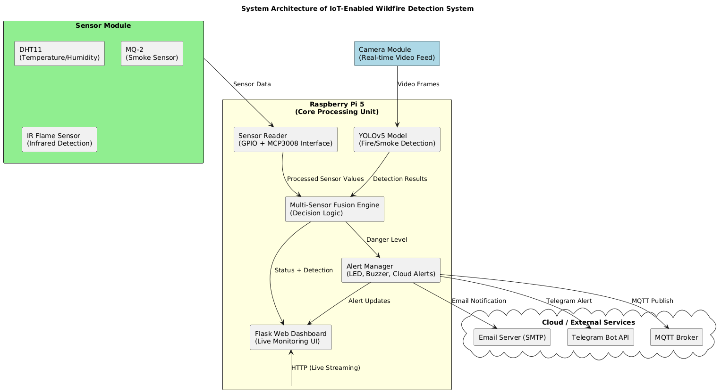
Figure 3.3.1 System architecture of the proposed IoT-enabled wildfire detection framework.

3.4 Data Flow Diagram (DFD)
1. Start & Input Phase
- Start: The initiation of the performance optimization cycle.
- User / Vehicle Input: The system accepts parameters from both the driver (user requests) and the vehicle's sensors. This includes real-time operational demands such as navigation requests, safety sensor triggers, or infotainment usage.
- On-Board Unit (OBU): The core hardware platform where the software resides. The OBU acts as the central hub for processing all incoming vehicle data and executing system commands.
2. Data Acquisition Phase
- Collect Performance Data (CPU, Memory, Network): The system monitors the "vitals" of the OBU hardware.
  - CPU: Tracks processing load and clock speeds.
  - Memory: Monitors RAM consumption to prevent system crashes.
  - Network: Measures data throughput (V2X communication) and latency.
3. Intelligence & Profiling Phase
- Capability Profiling: This is the core analytical step. The system determines the limitations and potential of the OBU at that specific moment. It creates a profile of how much "room" the system has to perform additional tasks without degrading performance.
- Data Analysis: The collected metrics are compared against the Capability Profile. The system identifies trends—such as whether a specific vehicle task is causing a memory leak or if the network bandwidth is insufficient for the current demand.
4. Optimization & Execution Phase
- Optimization Process: Based on the analysis, the system applies algorithms (often Machine Learning based) to find the most efficient way to run the current tasks. This involves re-prioritizing processes and streamlining data flow.
- Resource Allocation: This is the final action step where the optimization is physically applied. The OBU intelligently distributes its limited CPU cycles and Memory to the most critical tasks (e.g., prioritizing collision avoidance systems over music streaming).
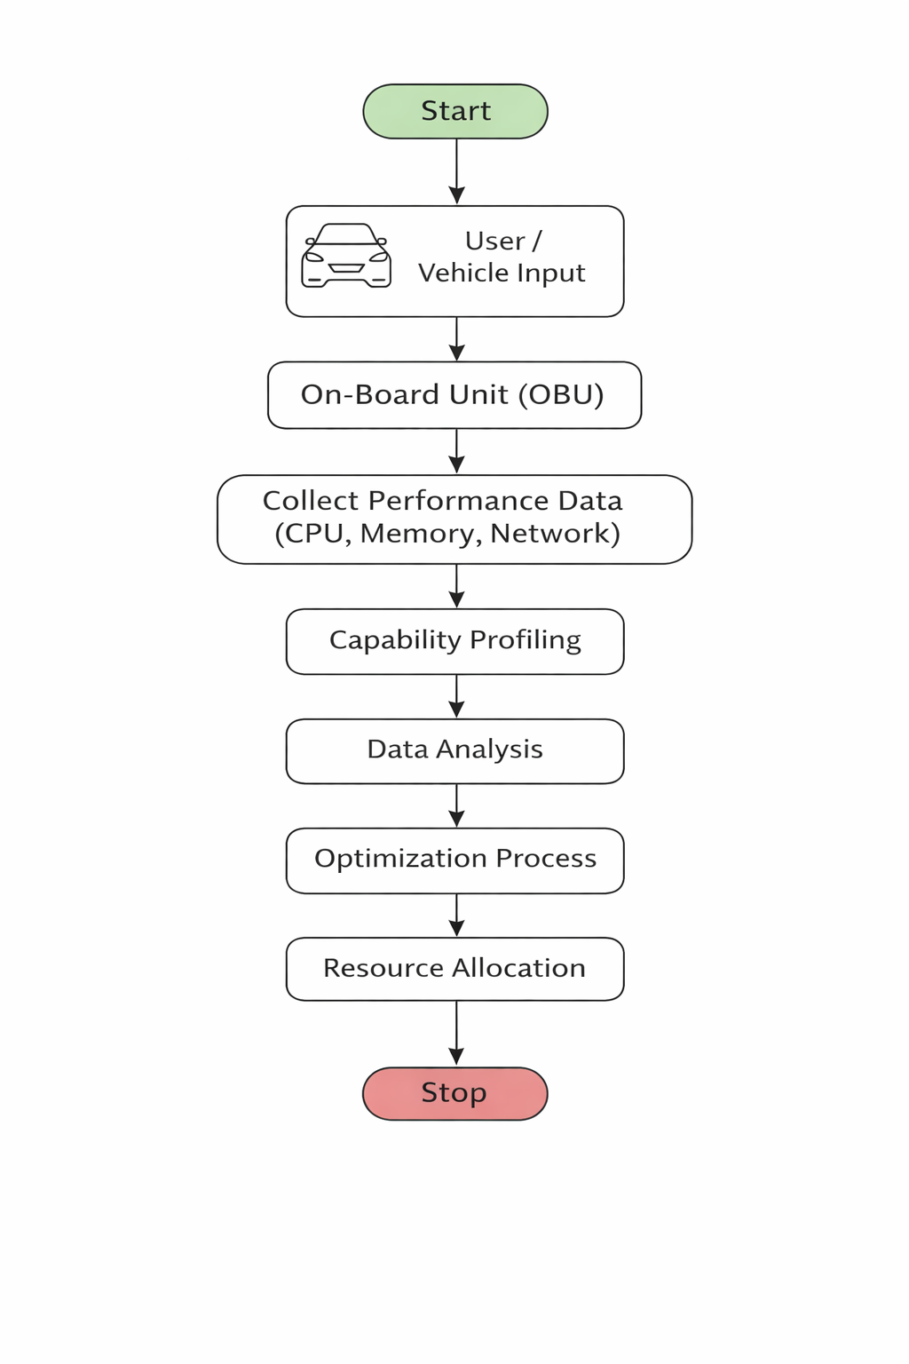
Figure 3.4:Data Flow Diagram

3.5 UML Diagrams
To ensure clarity and structured design, the system is modelled using the six essential UML diagrams:
3.5.1 Use Case Diagram
Purpose: Shows the interactions between the user and system functions.
Key Actors:
- System Administrator
- Monitoring Officer
- Raspberry Pi System
Main Use Cases:
- Start Detection
- View Live Dashboard
- Receive Alerts
- Access Sensor Data Logs
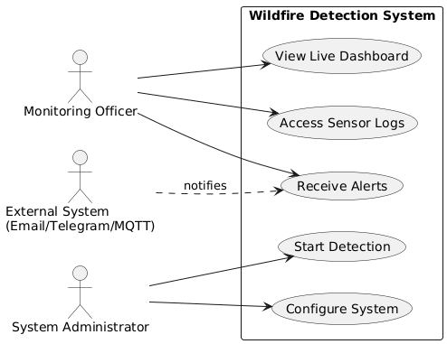
Figure 3.5.1.1 Use Case Diagram

3.5.2 Class Diagram
Purpose: Represents static structure and relationships among classes.
Key Classes and Attributes:
- CameraModule – init(), captureFrame()
- SensorModule – readDHT(), readMQ2(), readFlame()
- YOLOv5Detector – loadModel(), detect()
- FusionEngine – fuseData(), classifyAlert()
- AlertManager – sendEmail(), sendTelegram(), sendMQTT()
- Dashboard – updateLiveFeed(), displaySensors()
Relationships:
- Dashboard → FusionEngine (dependency)
- FusionEngine → Sensors & YOLOv5 (composition)
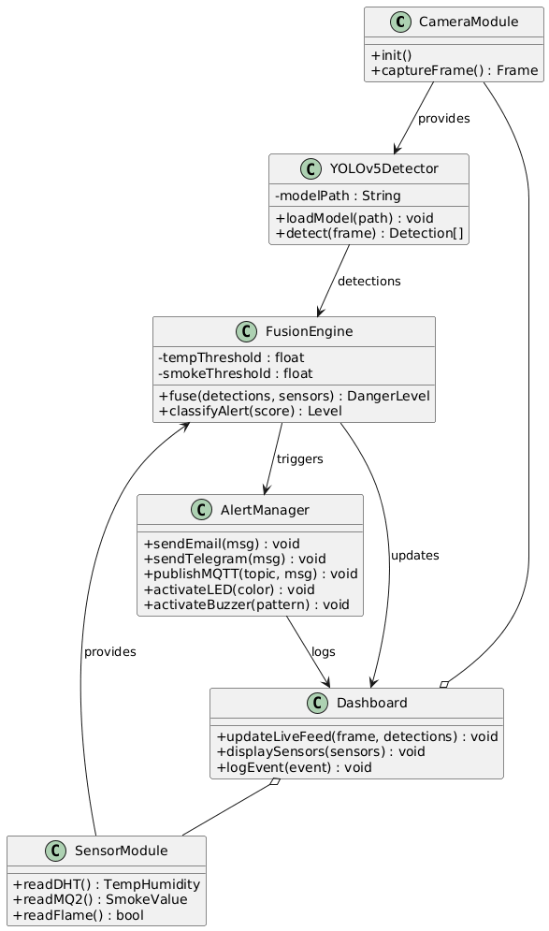
Figure 3.5.2.1 Class Diagram

3.5.3 Activity Diagram
Purpose: Describes system workflow.
Flow:
- Start
- Initialize all modules
- Capture frame
- YOLOv5 detection
- Read sensors
- Sensor + detection fusion
- Alert classification
- Trigger LEDs/Buzzer
- Send notifications
- Update dashboard
- Loop back to Step 3
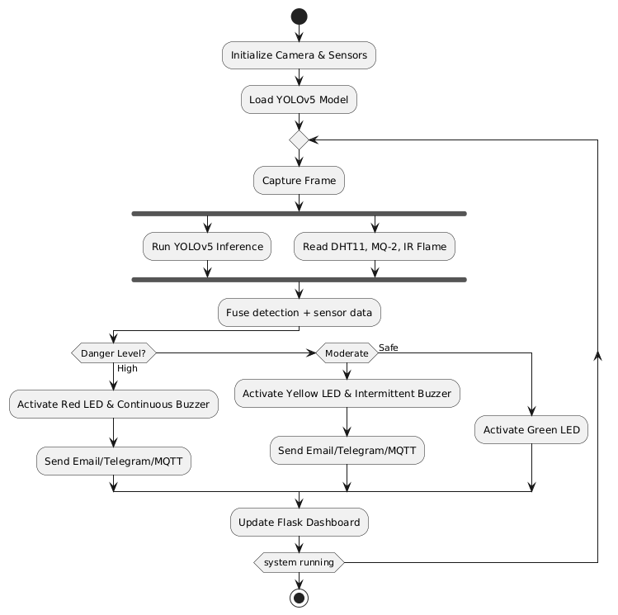
Figure 3.5.3.1 Activity Diagram

3.5.4 Sequence Diagram
Actors:
- User
- Dashboard
- Raspberry Pi
- YOLOv5 Model
- Sensor Module
- Alert Manager
Sequence Flow:
- User accesses dashboard
- Camera sends frame → YOLOv5 → detection
- Sensors → send readings
- FusionEngine → makes decision
- AlertManager → sends alerts
- Dashboard → updates UI
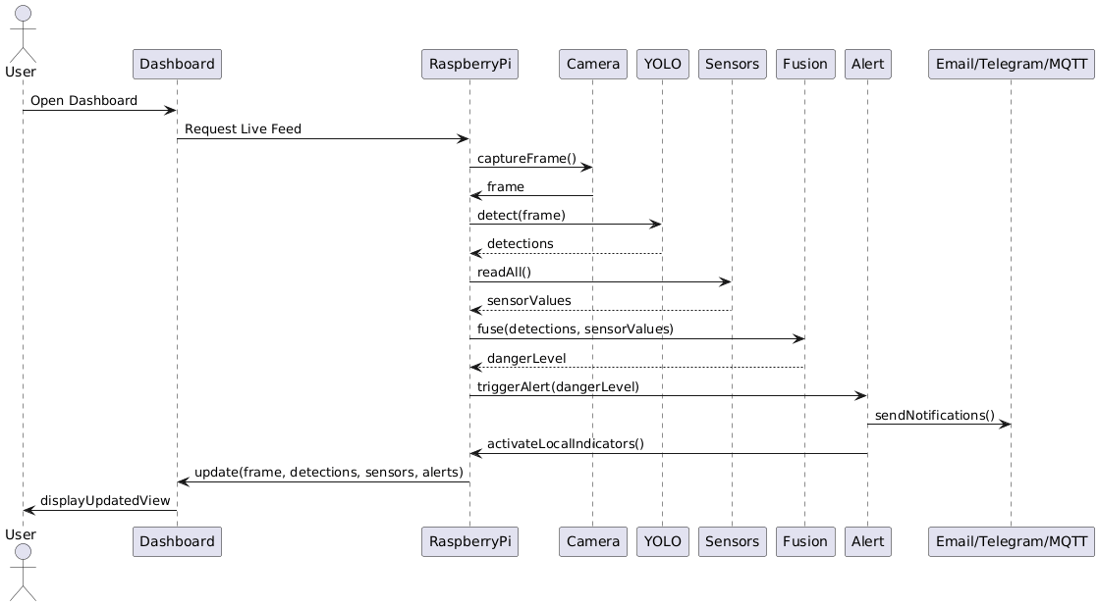
Figure 3.5.4.1 Sequence Diagram

3.5.5 Deployment Diagram
Nodes:
- Raspberry Pi 5
- Cloud Services (Email/Telegram/MQTT)
- Client Device (mobile/PC)
Artifacts Deployed:
- YOLOv5 model
- Flask web application
- GPIO sensor drivers
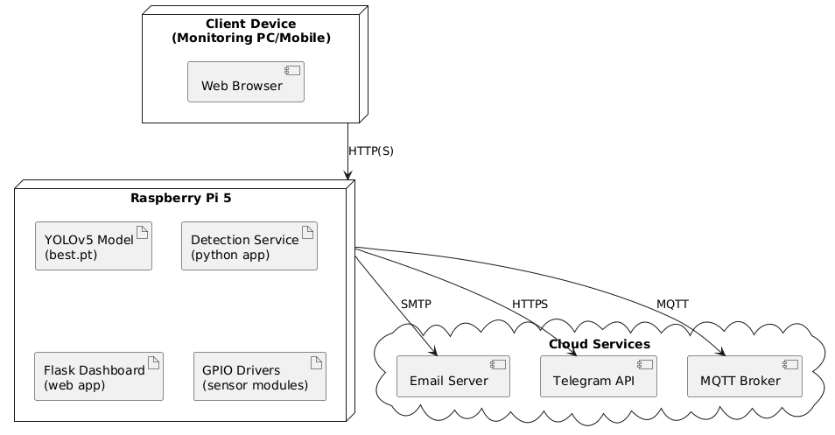
Figure 3.5.5 Deployment Diagram

3.5.6 Component Diagram
Components:
- YOLOv5 Detection Component
- Sensor Interface Component
- Fusion Engine Component
- Alert Component
- Dashboard Component
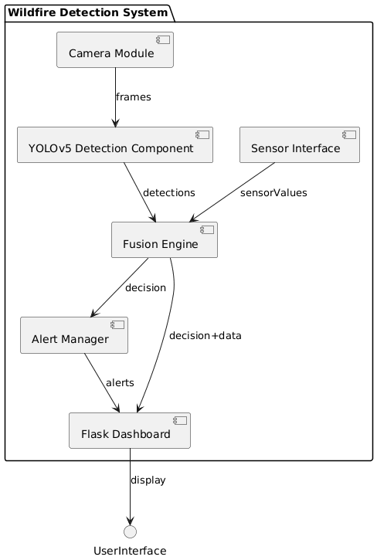
Figure 3.5.6 Component Diagram

3.6 Database Design / ER Diagram
The OBU Data entity contains real-time performance data collected from vehicle on-board units. It includes attributes such as obu_id (primary key), user_id (foreign key), CPU usage, memory usage, and network usage.
This entity is linked to the User, indicating that one user can have multiple OBU data records (one-to-many relationship).The Profiling entity is used to evaluate the performance of OBUs. It includes profile_id (primary key), obu_id (foreign key), capability score, and analysis timestamp. This table stores the results of capability profiling for each OBU.
The Optimization entity records the optimization actions taken based on profiling results. It includes opt_id (primary key), profile_id (foreign key), optimization action, result metrics, and timestamp.Overall, the relationships show that users generate OBU data, which is then profiled and optimized, forming a complete workflow from data collection to performance improvement.

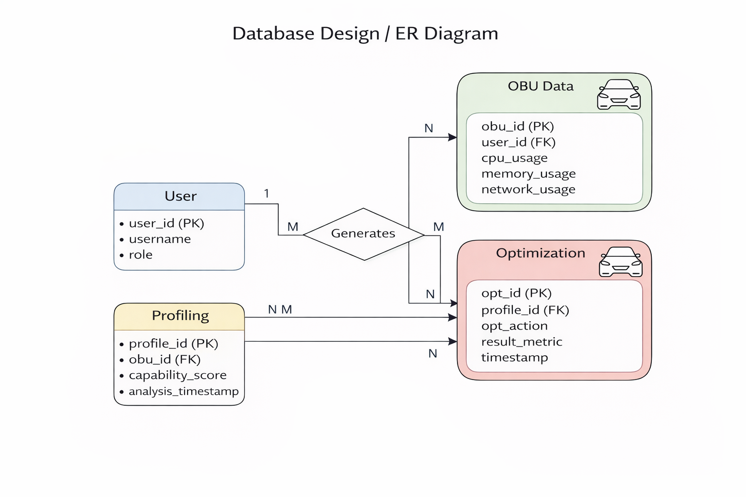
Figure 3.6 : Database Design / ER Diagram

CHAPTER 4
IMPLEMENTATION
4.1 Tools and Technologies
1. Python – Used as the main programming language for system development and data processing.
2. TensorFlow / Keras – Used to build and train machine learning models for performance optimization.
3. NumPy – Used for numerical computations and handling large datasets efficiently.
4. Pandas – Used for data analysis, preprocessing, and data manipulation.
5. Matplotlib – Used for visualizing performance metrics and results through graphs.
6. Tkinter – Used to develop a simple graphical user interface (GUI) for user interaction.
7. Jupyter Notebook – Used for model training, testing, and experimentation.
8. Scikit-learn – Used for implementing machine learning algorithms and evaluation.
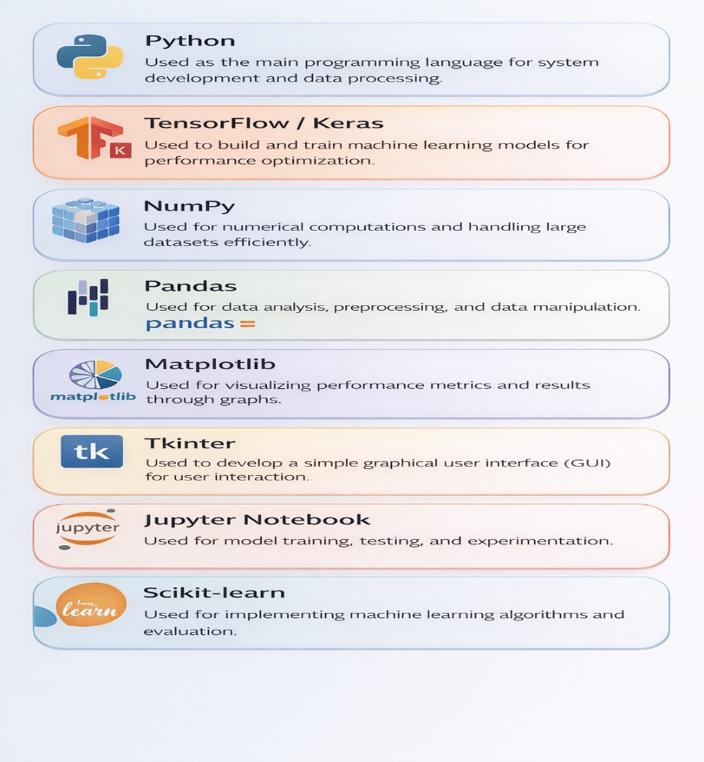
Figure 4.1: Tools and Technologies

4.2 Module Description
1. Data Collection Module
This module is responsible for collecting real-time data from the vehicle’s On-Board Unit. It gathers important parameters such as CPU usage, memory utilization, network usage, speed, and other vehicle-related metrics. The collected data acts as the input for further analysis and processing.
2. Data Preprocessing Module
The collected raw data is processed in this module to remove noise, inconsistencies, and missing values. It converts the data into a structured format suitable for analysis and machine learning models, ensuring accuracy and reliability.
3. Profiling Module
This module analyzes the processed data to evaluate the performance capabilities of the OBU. It identifies system behavior patterns and detects bottlenecks such as high latency, excessive CPU usage, or inefficient memory utilization.
4. Optimization Module
The optimization module uses machine learning techniques to enhance system performance. Based on profiling results, it applies optimization strategies like workload balancing, adaptive algorithms, and efficient data handling methods.
5. Resource Management Module
This module ensures optimal utilization of system resources such as CPU, memory, and network bandwidth. It dynamically allocates resources based on system demand to maintain smooth and efficient operation.
6. Visualization Module
The visualization module presents the system’s performance and optimization results using graphs, charts, and dashboards. It helps users easily understand system behavior and performance improvements.
7. GUI (Graphical User Interface) Module
This module provides a user-friendly interface for interacting with the system. Users can monitor real-time data, view analysis results, and control system functions easily through this interface.

8. Communication Module
This module handles data transmission between the vehicle, infrastructure, and external systems. It ensures reliable and efficient communication using appropriate protocols for real-time data exchange.

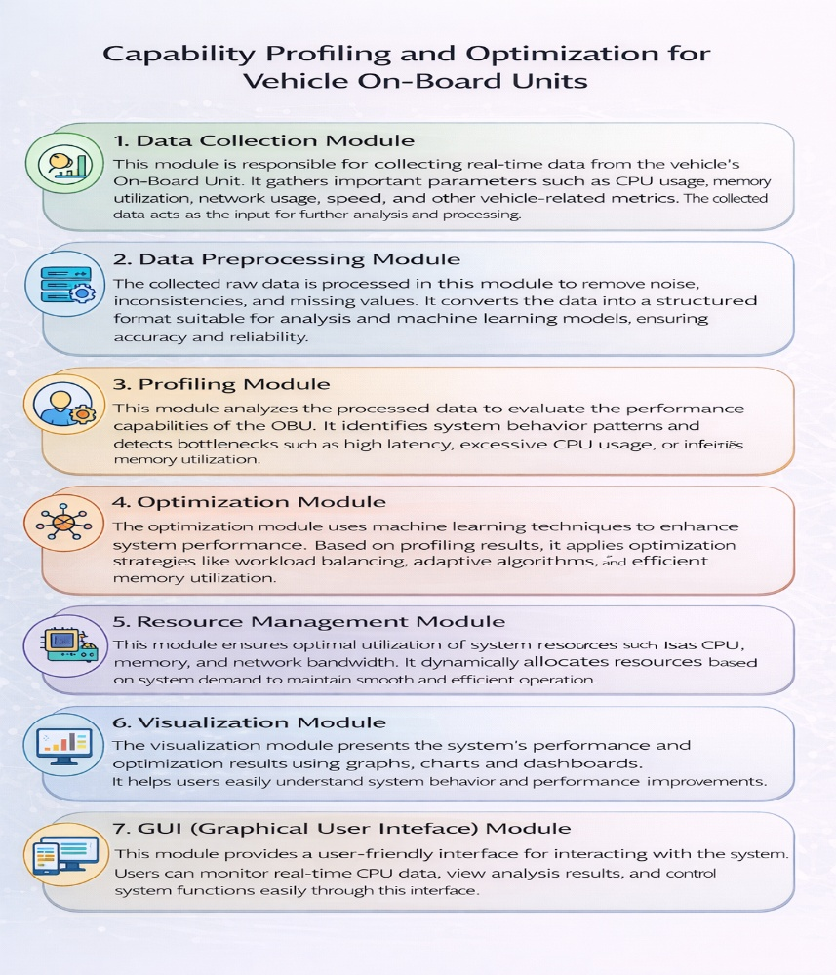
Figure 4.2 :Module Description
4.3 Algoritm / Methodology
1. Collect Performance Data from OBU
This step involves gathering real-time data from the vehicle’s On-Board Unit (OBU). Parameters such as CPU usage, memory consumption, network activity, speed, and other operational metrics are collected. This data provides the foundation for analyzing the system’s performance.
2. Preprocess and Clean the Data
The collected data is often raw and may contain noise, missing values, or inconsistencies. In this stage, data is cleaned, filtered, and transformed into a structured format to ensure accuracy and reliability for further processing.

3. Analyze System Metrics
In this phase, the processed data is analyzed to understand system behavior. Key performance indicators are evaluated to identify inefficiencies, bottlenecks, and abnormal patterns in the OBU.
4. Train Machine Learning Model
Using the analyzed data, machine learning models are trained to learn patterns and predict system performance. These models help in identifying optimal strategies for improving system efficiency.
5. Apply Optimization Techniques
Based on the model’s predictions, various optimization techniques are applied. These include efficient resource allocation, workload balancing, and adaptive algorithms to enhance overall system performance.
6. Evaluate System Performance
After applying optimization, the system’s performance is evaluated by comparing it with previous results. Metrics such as latency, resource usage, and efficiency are measured to determine improvements.
7. Display Optimized Results
Finally, the optimized results are presented using graphs, charts, or dashboards. This visualization helps users easily interpret system performance and understand the effectiveness of the optimization process.

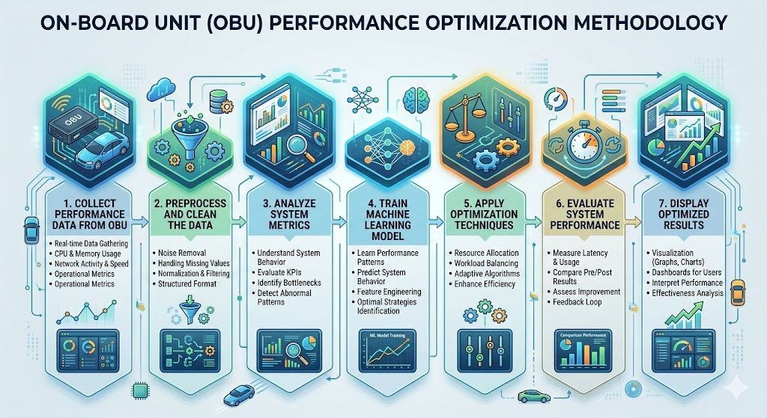
Figure 4.3: On-Board Unit (OBU) Performance Optimization Methodology

4.4 System Implementation
1. Real-Time Data Collection
The process begins with the seamless extraction of telemetry from the On-Board Unit.
- Mechanism: Utilizing high-speed sensors and kernel-level monitoring agents.
- Scope: Captures dynamic metrics including CPU cycles, memory buffers, network latency, and power consumption levels as they occur during vehicle operation.
2. System Processing and Analysis
Once ingested, the raw data undergoes rigorous computation to extract meaningful insights.
- Data Cleaning: Removing outliers and signal noise caused by vehicular vibrations or electromagnetic interference.
- Profiling: The system compares current usage against historical baselines to identify anomalies, bottlenecks, or underutilized hardware capabilities.
3. Application of Optimization Techniques
The core "intelligence" phase where the system decides how to improve performance.
- Strategy: Implementing techniques such as Dynamic Voltage and Frequency Scaling (DVFS), task re-prioritization, or load balancing.
- Goal: Ensuring that safety-critical applications (like autonomous braking sensors) receive maximum resources while secondary tasks (like firmware downloads) are throttled.
4. Model Training and Testing
To ensure the system evolves with the driver's habits and vehicle wear, a machine learning component is integrated.
- Training: The system uses the analyzed data to refine its predictive models, learning which optimization strategies yield the best results for specific driving conditions.
- Testing: Before full deployment, new optimization logic is tested in a "shadow mode" to ensure it meets safety and stability standards.
5. GUI Performance Display
The final stage bridges the gap between the machine and the user/administrator.
- Visualization: A Graphical User Interface (GUI) renders complex performance metrics into intuitive charts, gauges, and heatmaps.
- Accountability: This provides a clear view of the "Optimization Gain," allowing users to see exactly how much latency was reduced or how much energy was saved through the system’s actions.

CHAPTER 5
SOURCE CODE
import os
import numpy as np
import pandas as pd
import matplotlib.pyplot as plt
import seaborn as sns
import tkinter
from tkinter import messagebox, filedialog, simpledialog

from sklearn.model_selection import train_test_split

from sklearn.pipeline import make_pipeline
from sklearn.metrics import (
mean_absolute_error, mean_squared_error, r2_score,
precision_score, recall_score, f1_score, accuracy_score,
classification_report, confusion_matrix, roc_curve, auc
)
from sklearn.linear_model import LinearRegression, LogisticRegression
from sklearn.ensemble import RandomForestClassifier, RandomForestRegressor
from sklearn.svm import SVR, SVC
from sklearn.neighbors import KNeighborsClassifier, KNeighborsRegressor

import joblib
from joblib import dump, load

from tensorflow.keras.models import Sequential, load_model, Model
from tensorflow.keras.layers import Dense
from tensorflow.keras.optimizers import Adam

# Setting up directories
MODEL_DIR = 'models'
os.makedirs(MODEL_DIR, exist_ok=True)

RESULTS_DIR = 'results'
os.makedirs(RESULTS_DIR, exist_ok=True)
import os
import numpy as np
import pandas as pd
import matplotlib.pyplot as plt
import seaborn as sns
import tkinter
from tkinter import messagebox, filedialog, simpledialog

from sklearn.model_selection import train_test_split

from sklearn.pipeline import make_pipeline
from sklearn.metrics import (
mean_absolute_error, mean_squared_error, r2_score,
precision_score, recall_score, f1_score, accuracy_score,
classification_report, confusion_matrix, roc_curve, auc
)
from sklearn.linear_model import LinearRegression, LogisticRegression
from sklearn.ensemble import RandomForestClassifier, RandomForestRegressor
from sklearn.svm import SVR, SVC
from sklearn.neighbors import KNeighborsClassifier, KNeighborsRegressor

import joblib
from joblib import dump, load

from tensorflow.keras.models import Sequential, load_model, Model
from tensorflow.keras.layers import Dense
from tensorflow.keras.optimizers import Adam

# Setting up directories
MODEL_DIR = 'models'
os.makedirs(MODEL_DIR, exist_ok=True)

RESULTS_DIR = 'results'
os.makedirs(RESULTS_DIR, exist_ok=True)
df = load_dataset()
df
def preprocess_data(df, is_train=True, label_encoders=None):

df = df.loc[:, ~df.columns.str.contains('^Unnamed')] # Drop unnamed cols

if is_train:
label_encoders = {}

for col in df.select_dtypes(include='object').columns:
le = LabelEncoder()
df[col] = le.fit_transform(df[col].astype(str))
label_encoders[col] = le
else:
if label_encoders is None:
raise ValueError("label_encoders must be provided for test/inference.")

for col in df.select_dtypes(include='object').columns:
if col in label_encoders:
le = label_encoders[col]
df[col] = le.transform(df[col].astype(str))
else:
raise ValueError(f"Missing encoder for column: {col}")

df = df.fillna(df.mean(numeric_only=True))

if is_train:
X = df.drop(columns=['Eligible'])
y = df['Eligible']
return X, y, label_encoders
else:
return df
def perform_eda(df):

plt.figure(figsize=(18, 12))

# 1. Count Plot of Eligible Scores (Binned)
plt.subplot(2, 3, 1)
bins = pd.cut(df['Eligible'], bins=5)
sns.countplot(x=bins)
plt.title("Eligible Score Distribution (Binned)")
plt.xlabel("Eligible Range")
plt.ylabel("Count")

# 2. Box Plot: RAM vs Eligible
plt.subplot(2, 3, 2)
sns.boxplot(x=pd.cut(df['RAM'], bins=4), y=df['Eligible'])
plt.title("Eligible Score by RAM Ranges")
plt.xlabel("RAM Bins")
plt.ylabel("Eligible Score")

# 3. Box Plot: Storage vs Eligible
plt.subplot(2, 3, 3)
sns.boxplot(x=pd.cut(df['storage'], bins=4), y=df['Eligible'])
plt.title("Eligible Score by Storage Ranges")
plt.xlabel("Storage Bins")
plt.ylabel("Eligible Score")

# 4. Scatter Plot: Trustfactor vs Eligible
plt.subplot(2, 3, 4)
sns.scatterplot(x=df['Trustfactor'], y=df['Eligible'], color='green')
plt.title("Eligible Score vs Trustfactor")
plt.xlabel("Trustfactor")
plt.ylabel("Eligible Score")

# 5. Scatter Plot: TransmissionRate vs Eligible
plt.subplot(2, 3, 5)
sns.scatterplot(x=df['TransmissionRate'], y=df['Eligible'], color='purple')
plt.title("Eligible Score vs Transmission Rate")
plt.xlabel("Transmission Rate")
plt.ylabel("Eligible Score")

# 6. Correlation Heatmap
plt.subplot(2, 3, 6)
sns.heatmap(df.corr(), annot=True, cmap='coolwarm', fmt=".2f")
plt.title("Correlation Heatmap")

plt.tight_layout()
plt.savefig('results/system_eda_plots.png')
import os
from joblib import dump, load
from sklearn.linear_model import OrthogonalMatchingPursuit

def train_omp_regressor(X_train, y_train, X_test, y_test):
model_path = os.path.join(MODEL_DIR, 'omp_regressor.joblib')

if os.path.exists(model_path):
model = load(model_path)
print("Loaded Orthogonal Matching Pursuit Regressor model.")
else:
model = OrthogonalMatchingPursuit()
model.fit(X_train, y_train)
dump(model, model_path)
print("Trained and saved new Orthogonal Matching Pursuit Regressor model.")

y_pred = model.predict(X_test)
return evaluate_performance(y_test, y_pred, "Orthogonal Matching Pursuit Regressor")
plt.show()
def train_test_splitdata(X, y, test_size=0.3, random_state=42):
return train_test_split(X, y, test_size=test_size, random_state=random_state)
import os
from joblib import dump, load
from sklearn.neighbors import KNeighborsRegressor

def train_knn_regressor(X_train, y_train, X_test, y_test):
model_path = os.path.join(MODEL_DIR, 'knn_regressor.joblib')

if os.path.exists(model_path):
model = load(model_path)
print("Loaded KNN Regressor model.")
else:
model = KNeighborsRegressor(n_neighbors=5)
model.fit(X_train, y_train)
dump(model, model_path)
print("Trained and saved new KNN Regressor model.")

y_pred = model.predict(X_test)
return evaluate_performance(y_test, y_pred, "KNN Regressor")
X,y,label_names = preprocess_data(df,is_train=True)
X_train, X_test, y_train, y_test = train_test_splitdata(X, y)
train_decision_tree(X_train, y_train, X_test, y_test)
train_omp_regressor(X_train, y_train, X_test, y_test)
train_knn_regressor(X_train, y_train, X_test, y_test)
import os
from joblib import dump, load
from sklearn.ensemble import VotingRegressor
from sklearn.ensemble import RandomForestRegressor
from sklearn.linear_model import LinearRegression

def train_random_forest_linear_regressor(X_train, y_train, X_test, y_test):
model_path = os.path.join(MODEL_DIR, 'random_forest_linear_regressor.joblib')

if os.path.exists(model_path):
model = load(model_path)
print("Loaded Random Forest + Linear Regressor hybrid model.")
else:
rf = RandomForestRegressor(n_estimators=100, random_state=42)
lr = LinearRegression()

model = VotingRegressor(estimators=[
('rf', rf),
('lr', lr)
])

model.fit(X_train, y_train)
dump(model, model_path)
print("Trained and saved new Random Forest + Linear Regressor hybrid model.")

y_pred = model.predict(X_test)
return evaluate_performance(y_test, y_pred, "BranchLine Model ")
train_random_forest_linear_regressor(X_train, y_train, X_test, y_test)
create_comparison_table()
test_data = pd.read_csv('TestData.csv')
test_data
df1=preprocess_data(test_data, is_train=False,label_encoders=label_names)
df1
model_path = os.path.join(MODEL_DIR, 'random_forest_linear_regressor.joblib')
if os.path.exists(model_path):
rf_lr_model = load(model_path)
print("Hybrid Regressor Model Loaded.")
else:
raise FileNotFoundError("Model not found. Please train the model first.")
Y_reg = rf_lr_model.predict(df1)
BOLD = '\033[1m'
END = '\033[0m'

for i in range(len(df1)):
print("Sample Test Data:")
for col in df1.columns:
print(f"{col}: {df1.iloc[i][col]}")
print(f"{BOLD}Predicted Eligible Score: {Y_reg[i]:.6f}{END}")
print("\n\n\n\n\n")
output_data = [] # List to collect each row as dictionary

for i in range(len(df1)):
row_data = {}

# Add original test input features
for col in df1.columns:
row_data[col] = df1.iloc[i][col]

# Add only the regression prediction
row_data['Predicted Energy Efficiency Score'] = Y_reg[i]

output_data.append(row_data)

# Create and show final DataFrame
output_df = pd.DataFrame(output_data)
output_df

CHAPTER 6
RESULTS AND DISCUSSION
6.1 System Testing
Unit Testing
This stage focuses on validating individual components in isolation. Developers test the Data Collection scripts to ensure they pull correct CPU/RAM integers, and the Cleaning Module to verify it handles null values. Each function is treated as a "black box" to ensure logic accuracy before it merges with the larger system.
Integration Testing
Here, the focus shifts to the interfaces between modules. It verifies that the Data Analysis engine can successfully ingest the output from the Preprocessing layer. Crucially, it tests the hardware-software link, ensuring the software commands for resource re-allocation are correctly executed by the OBU’s kernel.
System Testing
This validates the complete, end-to-end workflow against the functional requirements. The system is tested as a whole—from the moment the vehicle starts and data is collected, through the ML-driven optimization, until the results are displayed on the GUI. This ensures the entire "Capability Profiling" loop works harmoniously in a simulated vehicle environment.
Performance Testing
Performance testing assesses the OBU’s stability under extreme conditions. Stress testing pushes the OBU to 99% load to observe the optimization's reaction time, while Load testing checks if the system can handle concurrent tasks (e.g., GPS, V2X, and updates) without exceeding a 100ms latency threshold. This guarantees that the optimization actually improves efficiency without introducing system lag.

6.2 Output Screens
1. Header & Filter Controls
- Context: Located at the top, it allows users to filter data by Formation (e.g., Strike Corps), Capability Area, and Time Horizon (Next 12 Months).
- Key Action: A prominent "Run Optimisation" button indicates the system’s ability to perform predictive modeling based on these filters.
2. High-Level KPI Tiles
Four primary metrics provide an instant status update:
- Total Units (12): The total number of units under the current selection.
- Avg Readiness (78%): The current operational state, showing a 4% improvement from the previous month.
- Critical Gaps (3): High-priority areas requiring immediate attention.
- Optimisation Score (82%): A measure of current efficiency with a highlight on potential gains.
3. Onward Units Capability Overview
This central table provides a granular breakdown of specific units (e.g., Armoured Brigade, Infantry Division):
- Readiness %: Uses color-coding (Green for high, Orange/Red for moderate/low) to indicate status.
- Key Strengths vs. Gaps: Identifies what each unit excels at (Firepower, Endurance) versus what it lacks (ISR, Air Defence).
4. Capability Distribution (Radar Chart)
A spider diagram visualizes five core dimensions: Firepower, Mobility, Survivability, C4ISR, and Sustainment.
- Current vs. Target: The solid blue line shows current capabilities, while the dashed green line represents the target, making it easy to see where the organization is "falling short."
5. Capability Gaps & Recommendations
This section translates data into actionable advice:
- Priority Mapping: Categorizes issues as High or Medium.
- Strategic Suggestions: Recommends specific actions, such as "Procure 2x SHORAD Systems," and predicts the Impact % of those actions.
6. Optimisation Impact Forecast
A predictive analysis window showing a transition from 78% Overall Effectiveness to a projected 86%.
- Financial & Time Logistics: Includes estimated investment (e.g., 125 Cr) and the implementation timeline (6 months).

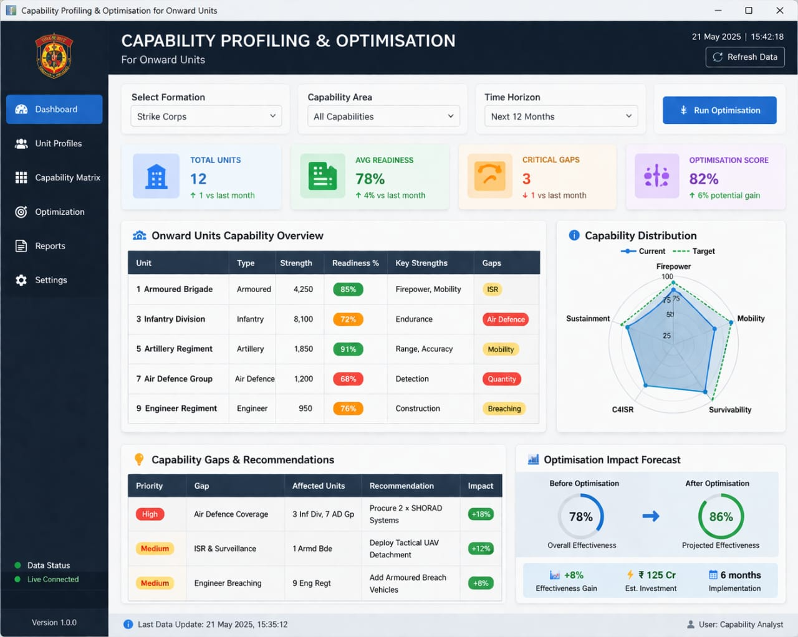
Figure 6.2: Output Screens
6.3 Performance Analysis
1. Eligible Score Distribution (Binned)
- Type: Histogram / Bar Chart.
- Description: This shows the frequency of OBUs falling into specific score ranges. The distribution follows a roughly "Normal Distribution" (bell curve), with the majority of units scoring in the middle range ($44.7$ to $62.7$), suggesting that most units meet standard capability requirements.
2. Performance Box Plots (RAM & Storage)

- Type: Box and Whisker Plots.
- Description: These two charts analyze how RAM and Storage capacities impact the Eligible Score.
  - Trend: As RAM and Storage bins increase, the median Eligible Score (the line inside the box) also rises.
  - Insight: This confirms that higher hardware specifications directly contribute to a higher capability profile for the OBU.
3. Relationship Scatter Plots (Trustfactor & Transmission Rate)
- Type: Scatter Plots.
- Description: These charts visualize the relationship between the Eligible Score and two operational variables:
  - Trustfactor: Shows a dense, positive correlation; as the trust in the unit's data increases, its eligibility score tends to rise.
  - Transmission Rate: Displays a similar upward trend, indicating that units capable of higher data throughput are rated more favorably.
4. Correlation Heatmap
- Type: Matrix Heatmap.
- Description: This is a statistical summary of how all variables relate to one another.
  - Key Finding: The "Eligible" row at the bottom shows positive correlation coefficients (ranging from $0.42$ to $0.47$) for RAM, Storage, Trustfactor, Distance, and TransmissionRate.
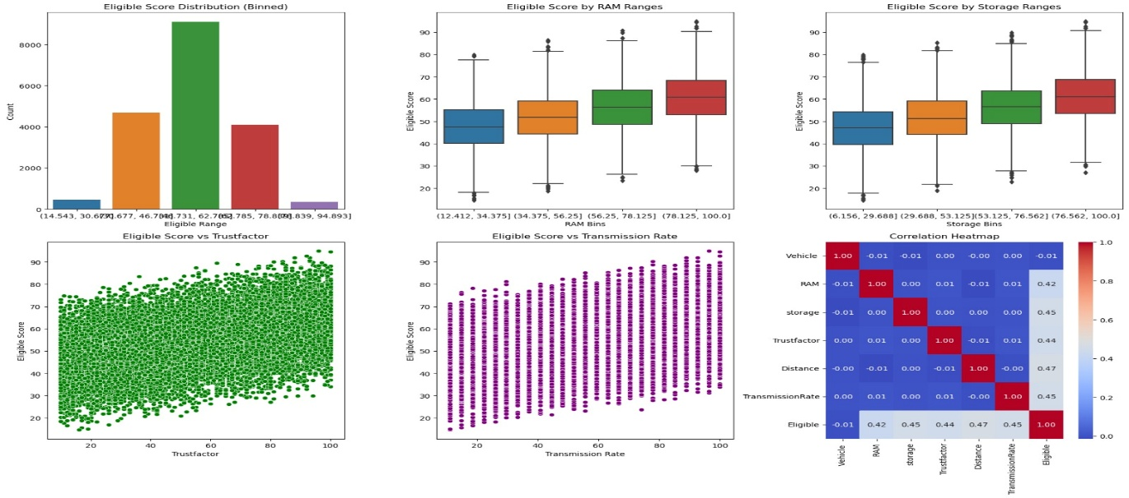

Figure 6.3:Performance Analysis

6.4 Advantages of the System
1. Guaranteed Mission-Critical Safety
The primary advantage is the enforcement of determinism in automotive software. In a standard OBU, a background update might compete for CPU cycles with an emergency sensor. This system uses real-time profiling to ensure that safety-critical applications (such as V2X collision warnings or autonomous braking logic) are granted absolute priority, effectively eliminating latency-related risks.
2. Enhanced Hardware Efficiency and Cost Savings
Manufacturers often over-spec hardware to account for "worst-case" load scenarios, which increases the vehicle's Bill of Materials (BOM). Capability profiling allows the OBU to operate closer to its theoretical limit by intelligently redistributing workloads. This means more features can be packed into more affordable hardware without compromising stability.
3. Extended Operational Lifespan
Continuous high-load operation leads to thermal stress, which degrades electronic components over time. The optimization engine monitors thermal deltas and applies Dynamic Voltage and Frequency Scaling (DVFS) to prevent overheating. By maintaining a balanced thermal profile, the system extends the physical lifespan of the OBU.
4. Power Optimization for Electric Vehicles (EVs)
In the era of electrification, every watt counts. The system reduces the OBU’s power footprint by throttling non-essential threads and optimizing network transmission rates. This energy efficiency directly contributes to a longer driving range and better battery health.
5. Future-Proofing via Scalability
As vehicles receive new features through Over-the-Air (OTA) updates, the OBU’s workload grows. A profiling system automatically adapts to these new requirements, re-tuning the resource allocation map to accommodate modern software without requiring expensive hardware retrofits.

CHAPTER 7
CONCLUSION AND FUTURE SCOPE
7.1 Conclusion
Capability profiling and optimization of Vehicle On-Board Units (OBUs) play a critical role in enhancing the performance, efficiency, and reliability of modern intelligent transportation systems. As vehicles increasingly rely on real-time communication, sensor integration, and edge computing, OBUs must be capable of delivering consistent processing power while maintaining minimal latency, energy efficiency, and secure data handling. Through systematic capability profiling, performance gaps—such as processing bottlenecks, memory constraints, communication delays, and computational load distributions—can be accurately identified.
Optimization techniques such as task offloading, adaptive resource allocation, hardware acceleration, and software-level tuning significantly improve the operational efficiency of OBUs. These strategies enable OBUs to support advanced applications including V2X communication, autonomous driving assistance, real-time navigation, predictive maintenance, and over-the-air updates. The result is a more scalable and future-ready platform capable of supporting emerging automotive standards and communication protocols.
Overall, capability profiling combined with targeted optimization ensures that OBUs evolve from simple communication modules into powerful, intelligent edge processors. This not only enhances vehicle safety and connectivity but also contributes to the broader vision of seamless, secure, and efficient smart mobility ecosystems.

7.2 Future Enhancements
1. 6G-Enabled Collaborative Edge Intelligence
The most significant leap will be the integration of 6G and Mobile Edge Computing (MEC). While current optimization is limited by the OBU’s local hardware, 6G will provide the ultra-low latency ($<1\text{ ms}$) and massive bandwidth required to offload heavy computational tasks to the edge. Future OBUs will act as "thin clients" that perform safety-critical tasks locally while offloading complex environment modeling and deep learning inference to edge servers. This collaborative approach removes the physical constraints of the OBU, allowing for "virtual" hardware scaling.
2. Federated Learning for Fleet-Wide Intelligence
Currently, optimization models are trained on historical data specific to a single vehicle. Future systems will utilize Federated Learning (FL) to enable fleet-wide optimization without compromising data privacy. In this setup, thousands of vehicles will share "model weights" representing local performance insights—such as how a specific OBU handles thermal stress in tropical climates—back to a central server. This collective intelligence allows the entire fleet to "learn" and receive optimized performance profiles via Over-the-Air (OTA) updates, ensuring every vehicle benefits from the experiences of the whole network.
3. Neuromorphic Computing Integration
To solve the "power-vs-performance" paradox in Electric Vehicles (EVs), future OBUs will likely integrate Neuromorphic chips. Unlike traditional Von Neumann architectures that consume power constantly, neuromorphic processors mimic the human brain's spiked neural networks, processing information only when a change in input is detected. Enhancing the profiling system to support these architectures would enable "event-driven optimization," where the system consumes near-zero power during steady-state driving but instantly scales to maximum capacity during an emergency maneuver.
4. Blockchain for Secure Capability Verification
As V2X (Vehicle-to-Everything) ecosystems grow, vehicles will need to "prove" their computational health to other entities in the smart city. Future enhancements could include a Blockchain-based Proof-of-Capability. A secure, immutable ledger would store the OBU’s current performance profile and safety certification. When entering a high-speed autonomous platoon, the vehicle would present this digital certificate to prove its OBU is optimized and capable of maintaining the required reaction times, preventing compromised or underperforming vehicles from endangering the traffic flow.

5. Quantum-Resistant Optimization and Security
As quantum computing threatens traditional encryption, the optimization engine itself must be secured. Future work involves implementing Post-Quantum Cryptography (PQC) within the OBU’s internal communication bus. This ensures that the optimization commands—which control critical resources like braking and steering logic—cannot be intercepted or manipulated by malicious actors using advanced computational attacks.
6. Digital Twin Integration for Predictive Maintenance
Finally, the OBU will be synchronized with a Cloud-based Digital Twin. This virtual replica of the vehicle’s hardware will run continuous simulations of potential failure modes. By comparing the real-time OBU profile with the Digital Twin, the system can predict hardware degradation months in advance, allowing for preemptive optimization to bypass failing components and scheduling maintenance before a breakdown occurs.

REFERENCES

[1] Shankar R, Marco J, Assadian F. The Novel Application of Optimization and Charge Blended Energy Management Control for Component Downsizing within a Plug‐in Hybrid Electric Vehicle. Energies. 2012; 5(12):4892-4923. https://doi.org/10.3390/en5124892
[2] Jiménez F, Cabrera-Montiel W. System for Road Vehicle Energy Optimization Using Real-Time Road and Traffic Information. Energies. 2014; 7(6):3576-3598. https://doi.org/10.3390/en7063576
[3] Wang S, Tao F, Shi Y, Wen H. Optimization of Vehicle Routing Problem with Time Windows for Cold Chain Logistics Based on Carbon Tax. Sustainability. 2017; 9(5):694. https://doi.org/10.3390/su9050694
[4] Levermore T, Sahinkaya MN, Zweiri Y, Neaves B. Real-Time Velocity Optimization to Minimize Energy Use in Passenger Vehicles. Energies. 2017; 10(1):30. https://doi.org/10.3390/en10010030
[5] Hur D-J, Jeong S-H, Song S-I, Noh J-H. Optimization Based on Product and Desirability Functions for Flow Distribution in Multi-Channel Cooling Systems of Power Inverters in Electric Vehicles. Applied Sciences. 2019; 9(22):4844. https://doi.org/10.3390/app9224844
[6] Kent T, Pipe A, Richards A, Hutchinson J, Schuster W. A Connected Autonomous Vehicle Testbed: Capabilities, Experimental Processes and Lessons Learned. Automation. 2020; 1(1):17-32. https://doi.org/10.3390/automation1010002
[7] Baz A, Yi P, Qurashi A. Intersection Control and Delay Optimization for Autonomous Vehicle Flows Only as Well as Mixed Flows with Ordinary Vehicles. Vehicles. 2020; 2(3):523-541. https://doi.org/10.3390/vehicles2030029
[8] Shokravi H, Shokravi H, Bakhary N, Heidarrezaei M, Rahimian Koloor SS, Petrů M. A Review on Vehicle Classification and Potential Use of Smart Vehicle-Assisted Techniques. Sensors. 2020; 20(11):3274. https://doi.org/10.3390/s20113274
[9] Zhu Y, et al. Vehicles OBU Computation Capability (VOCC) Dataset. Mendeley Data, V1, 2020. DOI: 10.17632/6fxbcs3hck.1
[10] Vo-Duy T, Ta MC, Nguyễn B-H, Trovão JPF. Experimental Platform for Evaluation of On-Board Real-Time Motion Controllers for Electric Vehicles. Energies. 2020; 13(23):6448. https://doi.org/10.3390/en13236448
[11] Xu N, Li X, Liu Q, Zhao D. An Overview of Eco-Driving Theory, Capability Evaluation, and Training Applications. Sensors. 2021; 21(19):6547. https://doi.org/10.3390/s21196547

[12] Ghoul T, Sayed T. Real-Time Safety Optimization of Connected Vehicle Trajectories Using Reinforcement Learning. Sensors. 2021; 21(11):3864. https://doi.org/10.3390/s21113864
[13] Ameen HA, Mahamad AK, Saon S, Malik RQ, Kareem ZH, Ahmadon MA Bin, Yamaguchi S. Identification of Driving Safety Profiles in Vehicle-to-Vehicle Communication System Based on Vehicle OBD Information. Information. 2021; 12(5):194. https://doi.org/10.3390/info12050194
[14] Shan D, Lei T, Yin X, Luo Q, Gong L. Extracting Key Traffic Parameters from UAV Video with On-Board Vehicle Data Validation. Sensors. 2021; 21(16):5620. https://doi.org/10.3390/s21165620
[15] Bethaz P, Cavaglion S, Cricelli S, Liore E, Manfredi E, Salio S, Regalia A, Conicella F, Greco S, Cerquitelli T. Empowering Commercial Vehicles through Data-Driven Methodologies. Electronics. 2021; 10(19):2381. https://doi.org/10.3390/electronics10192381
[16] Bučko B, Michálek M, Papierniková K, Zábovská K. Smart Mobility and Aspects of Vehicle-to-Infrastructure: A Data Viewpoint. Applied Sciences. 2021; 11(22):10514. https://doi.org/10.3390/app112210514
[17] Yu G, Liu S, Shangguan Q. Optimization and Evaluation of Platooning Car-Following Models in a Connected Vehicle Environment. Sustainability. 2021; 13(6):3474. https://doi.org/10.3390/su13063474
[18] Chen Y, Sun R, Wu X. Estimating Bounds of Aerodynamic, Mass, and Auxiliary Load Impacts on Autonomous Vehicles: A Powertrain Simulation Approach. Sustainability. 2021; 13(22):12405. https://doi.org/10.3390/su132212405
[19] Adelantado F, Ammouriova M, Herrera E, Juan AA, Shinde SS, Tarchi D. Internet of Vehicles and Real-Time Optimization Algorithms: Concepts for Vehicle Networking in Smart Cities. Vehicles. 2022; 4(4):1223-1245. https://doi.org/10.3390/vehicles4040065
[20] Pusztai Z, Kőrös P, Szauter F, Friedler F. Vehicle Model-Based Driving Strategy Optimization for Lightweight Vehicle. Energies. 2022; 15(10):3631. https://doi.org/10.3390/en15103631
[21] Al-Saadi M, Mathes M, Käsgen J, Robert K, Mayrock M, Mierlo JV, Berecibar M. Optimization and Analysis of Electric Vehicle Operation with Fast-Charging Technologies. World Electric Vehicle Journal. 2022; 13(1):20. https://doi.org/10.3390/wevj13010020
[22] Guerna A, Bitam S, Calafate CT. Roadside Unit Deployment in Internet of Vehicles Systems: A Survey. Sensors. 2022; 22(9):3190. https://doi.org/10.3390/s22093190
[23] Olariu S. Vehicular Crowdsourcing for Congestion Support in Smart Cities. Smart Cities. 2021; 4(2):662-685. https://doi.org/10.3390/smartcities4020034

[24] Pérez W, Tulpule P, Midlam-Mohler S, Rizzoni G. Data-Driven Adaptive Equivalent Consumption Minimization Strategy for Hybrid Electric and Connected Vehicles. Applied Sciences. 2022; 12(5):2705. https://doi.org/10.3390/app12052705
[25] Hanzl J, Pečman J, Bartuška L, Stopka O, Šarkan B. Research on the Effect of Road Height Profile on Fuel Consumption during Vehicle Acceleration. Technologies. 2022; 10(6):128. https://doi.org/10.3390/technologies10060128
[26] Croce AI, Musolino G, Rindone C, Vitetta A. Traffic and Energy Consumption Modelling of Electric Vehicles: Parameter Updating from Floating and Probe Vehicle Data. Energies. 2022; 15(1):82. https://doi.org/10.3390/en15010082
[27] Diachuk M, Easa SM. Improved Technique for Autonomous Vehicle Motion Planning Based on Integral Constraints and Sequential Optimization. Vehicles. 2022; 4(4):1122-1157. https://doi.org/10.3390/vehicles4040060
[28] Cai L, Zhang Q, Dai N, Xu Q, Gao L, Shang B, Xiang L, Chen H. Optimization of Control Strategy for Orderly Charging of Electric Vehicles in Mountainous Cities. World Electric Vehicle Journal. 2022; 13(10):195. https://doi.org/10.3390/wevj13100195
[29] Erdelić T, Carić T. Goods Delivery with Electric Vehicles: Electric Vehicle Routing Optimization with Time Windows and Partial or Full Recharge. Energies. 2022; 15(1):285. https://doi.org/10.3390/en15010285
[30] Ravi SS, Aziz M. Utilization of Electric Vehicles for Vehicle-to-Grid Services: Progress and Perspectives. Energies. 2022; 15(2):589. https://doi.org/10.3390/en15020589
[31] Guan T, Han Y, Kang N, Tang N, Chen X, Wang S. An Overview of Vehicular Cybersecurity for Intelligent Connected Vehicles. Sustainability. 2022; 14(9):5211. https://doi.org/10.3390/su14095211
[32] Campos-Ferreira AE, Lozoya-Santos JdJ, Tudon-Martinez JC, Mendoza RAR, Vargas-Martínez A, Morales-Menendez R, Lozano D. Vehicle and Driver Monitoring System Using On-Board and Remote Sensors. Sensors. 2023; 23(2):814. https://doi.org/10.3390/s23020814
[33] Sadaf M, Iqbal Z, Javed AR, Saba I, Krichen M, Majeed S, Raza A. Connected and Automated Vehicles: Infrastructure, Applications, Security, Critical Challenges, and Future Aspects. Technologies. 2023; 11(5):117. https://doi.org/10.3390/technologies11050117
[34] Luo W, Li X, Hu J, Hu W. Modeling and Optimization of Connected and Automated Vehicle Platooning Cooperative Control with Measurement Errors. Sensors. 2023; 23(21):9006. https://doi.org/10.3390/s23219006

[35] Liu Y, Yao C, Guo C, Yang Z, Fu C. Energy-Saving Optimization for Electric Vehicles in Car-Following Scenarios Based on Model Predictive Control. World Electric Vehicle Journal. 2023; 14(2):42. https://doi.org/10.3390/wevj14020042
[36] Liu Z, Wang W, He J, Zhang J, Wang J, Li S, Sun Y, Ren X. A New Hybrid Algorithm for Vehicle Routing Optimization. Sustainability. 2023; 15(14):10982. https://doi.org/10.3390/su151410982
[37] Mohammadi M, Fajri P, Sabzehgar R, Harirchi F. Autonomous Electric Vehicle Route Optimization Considering Regenerative Braking Dynamic Low-Speed Boundary. Algorithms. 2023; 16(6):262. https://doi.org/10.3390/a16060262
[38] Zhang L, Lu Y, Chen N, Wang P, Kong W, Wang Q, Qin G, Mou Z. Optimization of Roadside Unit Deployment on Highways under the Evolution of Intelligent Connected-Vehicle Permeability. Sustainability. 2023; 15(14):11112. https://doi.org/10.3390/su151411112
[39] Aletras N, Doulgeris S, Samaras Z, Ntziachristos L. Comparative Assessment of Supervisory Control Algorithms for a Plug-In Hybrid Electric Vehicle. Energies. 2023; 16(3):1497. https://doi.org/10.3390/en16031497
[40] Alolaiwy M, Hawsawi T, Zohdy M, Kaur A, Louis S. Multi-Objective Routing Optimization in Electric and Flying Vehicles: A Genetic Algorithm Perspective. Applied Sciences. 2023; 13(18):10427. https://doi.org/10.3390/app131810427
[41] Shahbazi Z, Nowaczyk S. Enhancing Energy Efficiency in Connected Vehicles for Traffic Flow Optimization. Smart Cities. 2023; 6(5):2574-2592. https://doi.org/10.3390/smartcities6050116
[42] Tsoukas V, Boumpa E, Chioktour V, Kalafati M, Spathoulas G, Kakarountas A. Development of a Dynamically Adaptable Routing System for Data Analytics Insights in Logistic Services. Analytics. 2023; 2(2):328-345. https://doi.org/10.3390/analytics2020018
[43] Vasile I, Tudor E, Sburlan I-C, Matache M-G, Cristea M. Optimization of the Electronic Control Unit of Electric-Powered Agricultural Vehicles. World Electric Vehicle Journal. 2023; 14(10):267. https://doi.org/10.3390/wevj14100267
[44] Justin S, Saleh W, Lashin MMA, Albalawi HM. Design of Metaheuristic Optimization with Deep-Learning-Assisted Solar-Operated On-Board Smart Charging Station for Mass Transport Passenger Vehicle. Sustainability. 2023; 15(10):7845. https://doi.org/10.3390/su15107845
[45] Kumar M, Panda KP, Naayagi RT, Thakur R, Panda G. Comprehensive Review of Electric Vehicle Technology and Its Impacts: Detailed Investigation of Charging Infrastructure, Power Management, and Control Techniques. Applied Sciences. 2023; 13(15):8919. https://doi.org/10.3390/app13158919

[46] Wei L, Liang L, Lei T, Yin X, Wang Y, Gao M, Liu Y. On-Board Unit (OBU)-Supported Longitudinal Driving Behavior Monitoring Using Machine Learning Approaches. Sensors. 2023; 23(15):6708. https://doi.org/10.3390/s23156708
[47] Ali WA, Fanti MP, Roccotelli M, Ranieri L. A Review of Digital Twin Technology for Electric and Autonomous Vehicles. Applied Sciences. 2023; 13(10):5871. https://doi.org/10.3390/app13105871
[48] Xu H, Zhang N, Li Z, Zhuo Z, Zhang Y, Zhang Y, Ding H. Energy-Saving Speed Planning for Electric Vehicles Based on RHRL in Car-Following Scenarios. Sustainability. 2023; 15(22):15947. https://doi.org/10.3390/su152215947
[49] Hermann D, Brousek J, Nemecek P. Method for the Conceptual Design of a New Mode of Urban Delivery Vehicle. World Electric Vehicle Journal. 2023; 14(12):323. https://doi.org/10.3390/wevj14120323
[50] Chauhan V, Chang C-M, Javanmardi E, Nakazato J, Lin P, Igarashi T, Tsukada M. Fostering Fuzzy Logic in Enhancing Pedestrian Safety: Harnessing Smart Pole Interaction Unit for Autonomous Vehicle-to-Pedestrian Communication and Decision Optimization. Electronics. 2023; 12(20):4207. https://doi.org/10.3390/electronics12204207
[51] Pires TR, Fernandes JFP, Branco PJC. Driving Profile Optimization for Energy Management in the Formula Student Técnico Prototype. Energies. 2024; 17(24):6313. https://doi.org/10.3390/en17246313
[52] Zhang C, Ji M, Wu Q, Fan P, Fan Q. Optimizing Age of Information in Internet of Vehicles over Error-Prone Channels. Sensors. 2024; 24(24):7888. https://doi.org/10.3390/s24247888
[53] Wang P, Ouyang T, Zhao S, Wang X, Ni Z, Fan Y. Intelligent Vehicle Formation System Based on Information Interaction. World Electric Vehicle Journal. 2024; 15(6):252. https://doi.org/10.3390/wevj15060252
[54] Garikapati D, Shetiya SS. Autonomous Vehicles: Evolution of Artificial Intelligence and the Current Industry Landscape. Big Data and Cognitive Computing. 2024; 8(4):42. https://doi.org/10.3390/bdcc8040042
[55] Al-refai G, Al-refai M, Alzu’bi A. Driving Style and Traffic Prediction with Artificial Neural Networks Using On-Board Diagnostics and Smartphone Sensors. Applied Sciences. 2024; 14(12):5008. https://doi.org/10.3390/app14125008
[56] Romero CA, Correa P, Ariza Echeverri EA, Vergara D. Strategies for Reducing Automobile Fuel Consumption. Applied Sciences. 2024; 14(2):910. https://doi.org/10.3390/app14020910
[57] Khanmohamadi M, Guerrieri M. Advanced Sensor Technologies in CAVs for Traditional and Smart Road Condition Monitoring: A Review. Sustainability. 2024; 16(19):8336. https://doi.org/10.3390/su16198336

[58] Wen J, Li L, Wu Q, Li K, Lu J. Multi-Objective Cooperative Adaptive Cruise Control Platooning of Intelligent Connected Commercial Vehicles in Event-Triggered Conditions. Actuators. 2024; 13(12):522. https://doi.org/10.3390/act13120522
[59] Zhang Q, Ikram M, Xu K. Online Optimization of Vehicle-to-Grid Scheduling to Mitigate Battery Aging. Energies. 2024; 17(7):1681. https://doi.org/10.3390/en17071681
[60] Rosero F, Rosero CX, Segovia C. Towards Simpler Approaches for Assessing Fuel Efficiency and CO₂ Emissions of Vehicle Engines in Real Traffic Conditions Using On-Board Diagnostic Data. Energies. 2024; 17(19):4814. https://doi.org/10.3390/en17194814
[61] Visconti P, Rausa G, Del-Valle-Soto C, Velázquez R, Cafagna D, De Fazio R. Innovative Driver Monitoring Systems and On-Board-Vehicle Devices in a Smart-Road Scenario Based on the Internet of Vehicle Paradigm: A Literature and Commercial Solutions Overview. Sensors. 2025; 25(2):562. https://doi.org/10.3390/s25020562
[62] Mansouri N, Mnassri A, Nasri S, Ali M, Lashab A, Vasquez JC, Guerrero JM. Control and Optimization of Hydrogen Hybrid Electric Vehicles Using GPS-Based Speed Estimation. Electronics. 2025; 14(1):110. https://doi.org/10.3390/electronics14010110
[63] Wang T, Qu D. Dynamic Stability Analysis and Optimization of Multi-Vehicle Systems in Heterogeneous Connected Traffic. Sensors. 2025; 25(3):727. https://doi.org/10.3390/s25030727
[64] Bilban M, İnan O. Optimizing Autonomous Vehicle Performance Using Improved Proximal Policy Optimization. Sensors. 2025; 25(6):1941. https://doi.org/10.3390/s25061941
[65] Zhang B, Shen G, Wang Y, Zhang Y, Zhang C, Wang X, Liu Z, Luo X. Multi-Objective Optimization of Speed Profile for Railway Catenary Maintenance Vehicle Operations Based on Improved Non-Dominated Sorting Genetic Algorithm III. Applied Sciences. 2025; 15(8):4361. https://doi.org/10.3390/app15084361
[66] Wang X, Chen T, Wang R, Lu J, Dou G. Review of State Estimation Methods for Autonomous Ground Vehicles: Perspectives on Estimation Objects, Vehicle Characteristics, and Key Algorithms. Sensors. 2025; 25(13):3927. https://doi.org/10.3390/s25133927
[67] Wang D, Zheng W, Zhou H. Robust Optimization for Electric Vehicle Routing Problem Considering Time Windows Under Energy Consumption Uncertainty. Applied Sciences. 2025; 15(2):761. https://doi.org/10.3390/app15020761
[68] Cao H, Zhao J. Optimizing Modular Vehicle Public Transportation Services with Short-Turning Strategy and Decoupling/Coupling Operations. Sustainability. 2025; 17(3):870. https://doi.org/10.3390/su17030870

[69] Husyeva II, Navas-Delgado I, García-Nieto J. Data-Driven Approaches for Efficient Vehicle Driving Analysis: A Survey. Journal of Sensor and Actuator Networks. 2025; 14(3):52. https://doi.org/10.3390/jsan14030052
[70] Arslan M, Karamangil Mİ. Comprehensive Optimization and Design of an Electric Vehicle Battery Box Side Profile for Lightweight and Crashworthiness Using a Novel Hybrid Structure. Applied Sciences. 2025; 15(4):2037. https://doi.org/10.3390/app15042037
[71] Palamutçuoğlu BT, Çavuşoğlu S, Çamlı AY, Virlanuta FO, Bacalum S, Züngün D, Moisescu F. Solution of the Capacity-Constrained Vehicle Routing Problem Considering Carbon Footprint Within the Scope of Sustainable Logistics with Genetic Algorithm. Sustainability. 2025; 17(2):727. https://doi.org/10.3390/su17020727
[72] Almutairi A, Owais M. Reliable Vehicle Routing Problem Using Traffic Sensors Augmented Information. Sensors. 2025; 25(7):2262. https://doi.org/10.3390/s25072262
[73] Youssef B. A Robust Adaptive Strategy for Diesel Particulate Filter Health Monitoring Using Soot Sensor Data. Vehicles. 2025; 7(2):39. https://doi.org/10.3390/vehicles7020039
[74] Šarkan B, Loman M, Caban J, Malek A, Richtář M, Stopková M. Changing Fuel Consumption Data in Official Vehicle Documents—Case Study in the Slovak Republic. Vehicles. 2025; 7(1):27. https://doi.org/10.3390/vehicles7010027
[75] Dafhalla AKY, Ahmed AET, Sid Ahmed NMO, Filali A, Alhomed LS, Ali FAE, Eldeen AIG, Elobaid ME, Adam T. High-Performance Data Throughput Analysis in Wireless Ad Hoc Networks for Smart Vehicle Interconnection. Computers. 2025; 14(2):56. https://doi.org/10.3390/computers14020056
[76] Kavitha C, Gautam G, Sudeep R, Kannan C, Ashok B. Hybrid Vehicle Battery Health State Estimation Based on Intelligent Regenerative Braking Control. World Electric Vehicle Journal. 2025; 16(5):280. https://doi.org/10.3390/wevj16050280
[77] Sardar SA, Iqbal S, Park J, Han S, Kim WY. Field Data Retrieval for Electric Vehicles and Estimating Equivalent Circuit Model Parameters via Particle Swarm Optimization. Technologies. 2025; 13(3):91. https://doi.org/10.3390/technologies13030091
[78] Dafhalla AKY, Isam HM, Ahmed AET, Ahmed IS, Alhomed LS, Zahou AMe, Ali FAE, Zayan DMI, Elobaid ME, Adam T. Performance Evaluation and QoS Optimization of Routing Protocols in Vehicular Communication Networks Under Delay-Sensitive Conditions. Computers. 2025; 14(7):285. https://doi.org/10.3390/computers14070285

[79] Nasri S, Mansouri N, Mnassri A, Lashab A, Vasquez J, Rezk H. Global Analysis of Electric Vehicle Charging Infrastructure and Sustainable Energy Sources Solutions. World Electric Vehicle Journal. 2025; 16(4):194. https://doi.org/10.3390/wevj16040194
[80] Kiani H, Vahidi B, Hosseinian SH, Lazaroiu GC, Siano P. Prospective Design and Evaluation of a Renewable Energy Hybrid System to Supply Electrical and Thermal Loads Simultaneously with an Electric Vehicle Charging Station for Different Weather Conditions in Iran. Smart Cities. 2025; 8(2):61. https://doi.org/10.3390/smartcities8020061

